Prof.V.B.Shah Institute of Management &R.V.Patel College of Commerce (Eng. Med.)&V.L.Shah College of Commerce

(Guj.Med.) &

Sutex Bank College of Computer Applications & Science, Amroli

**(Accredited ‘B’ (CGPA 2.55) by NAAC Dec.-2009)**

**VEER NARMAD SOUTH GUJARAT UNIVERSITY, SURAT**



**PROJECT REPORT**

**ON**

**RENT2RIDE**

**AS A PARTIAL REQUIREMENT FOR THE DEGREE**

**OF**

**BACHELOR OF COMPUTER APPLICATION**

**(B.C.A.)**

**SUBMITTED BY:**

**Rajal M. Thummar (598)**

**Drashti G. Vekariya (621)**

**Jinal N. Virani (624)**

**Palak N. Virani (625)**

**GUIDED BY:**

**Dr. Hiral D. Patel**



# Certificate

This is to certify that the project titled “Rent2Ride” is the bonafide work carried out by Rajal M. Thummar(598)­, Drashti G. Vekariya (621), Jinal N. Virani(624),Palak N. Virani(625)students of TYBCA Sem-VI of Sutex Bank College of Computer Application and Science, Amroli, (Surat) affiliated to Veer Narmad South Gujarat University. He/she has successfully completed his/her project work in partial fulfillment of the requirements for the award of the degree of "Bachelor of Computer Application" during the academic year 2019-2020. And that the project has not formed the basis for the award previously of any other degree, diploma, fellowship or any other similar title.

## ­­­­­­­­­­­­­­­­­­­­ ACKNOWLEDGEMENT

We would like to express our gratitude towards my parents &Faculties of Our College for their kind co-operation and encouragement which help us in completion of this project. They are the person who gives solution whenever needed.

­­­­­­Dr.Hiral D. Patel our professor and project co-ordinates has been very prudent to us threw out the collage studies. They ate the person who has giving this direction to our work and the shape to our imagination. We express our regard to them from the core of our heart.

My thanks and appreciations also go to my colleague in developing the project and people who have willingly helped me out with their abilities.

Success is such a comprehensive project cannot achieve single-handed. It is team effort that sails the ship to the coast. So we would like to express our sincere thanks to all the dignitaries who were involved in making this project the great joy and turning it our into successful piece of work.

We would also like to acknowledge all the friends and colleagues, team member for the help and encouragement by them for time to time. The constant support and encouragement of my friend is deeply appreciates. The project indeed gave challenging and exhilarating experience in designing and developing the required system.

**INDEX**

|  |  |
| --- | --- |
| **Chapter** | **Page No.** |
| **1. Introduction**   * 1. Project description   2. Project Profile   **2. Environment Description**   * 1. Hardware and Software Requirements   2.2 Technologies Used  **3. System Analysis and Planning**   * 1. Existing System and its Drawbacks   2. Feasibility Study   3. Requirement Gathering and Analysis   **4. Proposed System**  4.1 Scope  4.2 Project modules  4.3 Module vise objectives/functionalities Constraints  4.4 Expected Advantages  **5. Detail Planning**  5.1 Data Flow Diagram / UML  5.2 Process Specification / Activity Flow Diagram  5.3 Data Dictionary  5.4 Entity-Relationship Diagram / Class Diagram  **6. System Design**  6.1 Database Design  6.2 Directory Structure  6.3 Input Design  6.4 Output Design  **7. Software Testing**  **8. Limitations and Future Scope of Enhancements References** | **1-3**  2  3  **4-6**  5  6  **8-12**  9  10  12  **14-17**  15  15  16  17  **18-39**  19  26  32  39  **40-57**  41  56  57  57  **75-78**  **79-81** |

­­­­­­­­­­­

**1.1 Project Description**

**1.2 Project Profile**

**1.1 Project Description**

The rent2ride system is being developed for rental buyer. They can book a car and bike as per their requirement. Our website takes information from the rental buyer through the registration and book car and bike with rent. The proposed system is completely integrated online system.

This automated system facilitates rental buyer and provides to fill up the details according to their requirements.Our system provides car and bike to rental buyers with different brand and model the purpose of this system is to develop a web site for the people who can book their car and bike along with requirements. **1.2 ProjectProfile**

|  |  |
| --- | --- |
| Project Title | RENT2RIDE |
| Organization | Sutex Bank College Of Computer Applications & science , Amroli |
| Operating System | Microsoft Windows 10 |
| Technology | MySQLi, Java |
| Front End Used | Laravel With PHP |
| Back End Used | MySQLi |
| Project Duration | 3 Month |
| Project Guide | Dr.Hiral D. Patel |
| Submitted To | Sutex Bank College Of Computer Applications & science , Amroli |
| Developed By | RajalThummar (598)  DrashtiVekariya (621)  Jinal Virani (624)  Palak Virani (625) |

**­­­­­­­ 2.1 Hardware & Software**

**­­­­­­­­­­­­­­­­­­­­­­­­­­­­­­­­­­­­­­­­ 2.2 Technologies Used**

**2.1 Hardware & Software**

The efficient hardware and software configuration requires running the system is as suggested below. The configuration suggested is for better performance. Same functionality or higher configuration will always be better.

**Development Side**:

|  |  |
| --- | --- |
| Hard Disk | 50 GB |
| Processor | Intel i5 7thgeneration & supporting |
| O.S. | WindowsXP,Windows7, Windows 8, Windows 10, |
| Memory(Ram) | 4 GB |
| Web Browser | Google Chrome etc… |

**2.2 Technology Used**

**Core Technology**

|  |  |  |
| --- | --- | --- |
| **Admin** | **Documentation Tools** | **Extra Technology** |
| PHP –Front End | EDraw | JQuery |
| MySQL–Back End | MS Word | Java Script |
| HTML | MS Excel | AJAX |
| CSS | MS PowePoint | **--** |

**About PHP**

Precisely, PHP is a very powerful server-side scripting language like ASP for developing dynamic web applications. Using PHP, you can build interactive and dynamic websites with ease. If you have some idea about the C language then learning PHP should be a fairly simple task for you.

It is suitable for web development, it is efficient. PHP script can be embedded straight into the heart of html code just like ASP.One of the reasons of the why PHP is getting more popular is that its syntax is very much like that of C. However, it is mostly used with MySQL. Another reason for the ever increasing popularity of PHP is that it is free to download and use.

**About MySQLi**

The PHP code consists of a core, with optional extensions to the core functionality. PHP's MySQL-related extensions, such as the MySQLi extension, and the MySQL extension, are implemented using the PHP extension framework.

An extension typically exposes an API to the PHP developer, to allow its facilities to be used programmatically. However, some extensions which use the PHP extension framework.

MySQLi is an improved version of the older PHP MySQL driver, offering various benefits.

**3.1 Drawbacks of Existing System**

**3.2 Feasibility Study**

**3.3Requirement Analysis and**

**Data Gathering**

**3.1 Existing System and its Drawbacks**

**Slow, tedious, time consuming:**

Searching a record of a particular consumer from a big fat registers is certainly a very time consuming and tedious task. This is because requires the managers to go through all the ledgers and search the particular record from a set of 500 to 1000 records or even much more than that.

**Lack of security:**

Since the different information pertaining to a consumer is maintained in a register and stored in cupboards, drawers etc.E.g. any changes in the connected load or maximum demand may end up being very expensive for the organization as a whole.

**Fewer Discounts:**

Other car rental, you may get a discount just for using a certain type of credit card or placing your reservation online. Used car rentals rarely offer such a breadth of discounts, so while you may plan to save money by renting used, your total cost could be higher than going with a newer car.

**Vehicle Problems:**

The prospect of renting a several year old vehicle could be terrifying if you plan to drive it a long distance. While new rental cars are maintained meticulously, their used car counterparts may not be maintained as well.

**3.2 Feasibility Study**

Feasibility is the measure of how beneficial an information system will be to an organization. A feasibility study looks at the viability of an idea with an emphasis on identifying potential problems.

**Operational Feasibility:**

The main goal of this project is to provide a system that will be useful and beneficial to the user. All the requirements needed for this system requires and necessary to the client requests. Thus, this system acquires information inputs from the user and generates reports so that the client can monitored their entire vehicle, drivers and booking transactions information.The information acquired from the user will be safely stored in one database and be well monitored.

**Technical Feasibility:**

Vehicle Booking and Management System would be able to save time and efforts of employees of the company. The researches that are involved with this project would undergo the same process, hand in hand. As the system continues to develop, the researchers will be likewise. The checking also of the software and the hardware conditions should be a must because the developing of the system is dependent on those things. The researchers would develop the system every time and implementing all the learning that they have.

**Economic Feasibility:**

How the system would be able to work with the approved budget proposal any modification will be made as long as some alternatives were applicable andapproved.When exploring the economic feasibility of the system a cost benefit analysis would evaluate the benefits of the system against its costs.

**Management Feasibility:**

Management feasibility is not comes in basic feasibility of system, but it’s arise an aspect of management views. Here all level of management revise all related basic feasibilities and know the requiredness of that all, after that all manager gives their decision for all those feasibility to use or not.

**Time Feasibility:**

Time feasibility describes the time cost for converting the existing system to new system. As an aspect of time feasibility our system takes three months for completion. This System is Develop under the time period of just three months so we can say that this system is time Feasible.

**3.3 Requirement Analysis and Data Gathering**

**Requirement Analysis:**

We analyzed our gathered information and we have decided our system should have following functionalities.

**Authentication of members :( Admin, Owner, User)**

* Creation of owner account
* Deletion of owner/user account
* Authorization of owner/user account
* Admin

**Different types of module**

* Login
* User Management
* Owner Management
* Vehicle Management
* Area Management

**Admin**

* Manage Vehicle
* Area Management
* Banner Management
* View Report

**Owner**

* Login
* Manage Vehicle booking
* Manage inquiry
* Account Management

**User**

* Manage Profile
* Give Rating
* Give Payment
* Search Vehicle

**Requirement Gathering**

The requirement gathering process is mainly focused on software to understand the nature of the program to build. The software engineering or analyst must understand the information domain for the software as well as required function, behavior and performance as well as interface for the software requirement for both the system and the software are documented and review with the user.

**Understanding the process of security system:**

What type of activities should be included?

How to manage all activities?

How to manage reminder process?

How to manage login and logout process?

How to manage all activities linked with each other?

How to manage intercommunication with internet?

How to manage the bunch of data of particular rental buyers so that it can have the security purpose and keep the data private.

**4.1 Scope**

**4.2 Objective**

**4.3 Constrain**

**4.4 Expected Advantages**

**4.1 Scope**

* Authorized login, secure and user friendly.
* This project satisfies the rental buyer’s need and Store every data in form of records as a softcopy so as to reduce storage spaces and also reduce manual date entry errors.
* Maintain databases so that data can be easily accessible in less time and efforts.
* The data is accessible even if rental buyer or worker loses his/her files because the data is stored on the server.

**4.2 Objective**

The main purpose of our system is to give rental buyers the car and bike on rent.

This automated system facilitates rental buyer and provides to fill up the details according to their requirements.Our system provides car and bike to rental buyers with different brand and model. The purpose of this system is to develop a web site for the people who can book their car and bike along with requirements.

**Faster Process**:

To make sure a user get his desire car as early as possible, the car rental management system will provide the faster response to complete the process

**Minimize paperwork**:

As all the system is computerized, there is no need to fill any application from for renting purpose. So the paperwork will be very less.

**Centralized:**

All type of data and the activities related to system will be kept in a single place so that it is easy to monitor the system and provide the rental buyer the best service.

**4.3 Constraints**

Some of the constraints are listed below with which we have developed this system:

**Strict Terms and Conditions**

At some rental car agencies, it is their policy to provide stringent condition. Perhaps this is intended so that renters should be careful in using the vehicles that they have rented. However, this should only be considered on a conditional basis. Some people may find this very inconvenient which can affect the reputation of that particular agency.

**Limited Variety of Car Models**

For most renters, renting a car should depend on the make or model of the said vehicle. Most car rental shops offer the same make and model which users admit that they often run out of variety.

**Different driving styles**

Each new driver will naturally drive the car a little differently than the last.Many rental buyers are reluctant to drive, so there is a higher risk of damage to the vehicle.

**4.4 Expected Advantages**

* Due to the competition among offices and car rental companies, they usually offer really good deals and a wide range of cars.
* Can be guided by GPS or different apps to mobilized by the country.
* Ranging from classic to exotic racing cars, you can get any car of choice as long it is available in rental center create company.
* Some rental companies, just more up to date models have been utilized for their rental administrations.
* Multiple entry points from facebook, google, linked in comforts users to enter the system easily.

**5.1 Data Flow Diagram**

**5.2 Process Specification**

**5.3 Data Dictionary**

**5.4 ER Diagram**

**5.1 Data Flow Diagram**

**Data Flow Diagram**

The data flow diagrams are an intuitive way of showing how data is processed by a system. The symbols used in the DFD for this project are shown below.

|  |  |  |
| --- | --- | --- |
| **Symbol** | **Name** | **Function** |
|  | **Data flow** | Following symbol is used to show data flow. The data flow is packet of data. |
|  | **External entity** | An external entity sends or receives data from the system. It can represent a person, a machine an organization etc., |
|  | **Process** | People, procedures or devices that use or produce data. |
|  | **Data storage** | Here data are stored or referenced process in the system. |

**0 Level DFD**

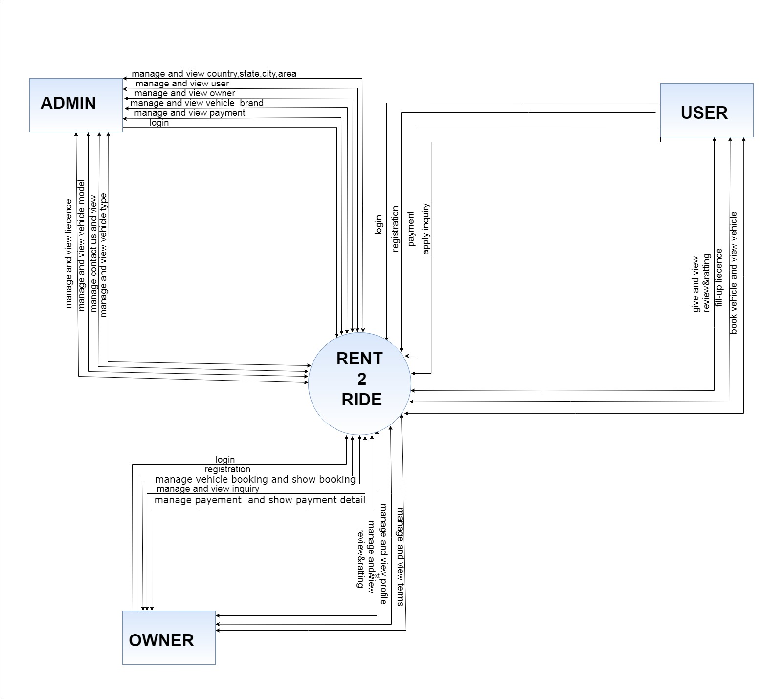 **1st Level DFD for admin**

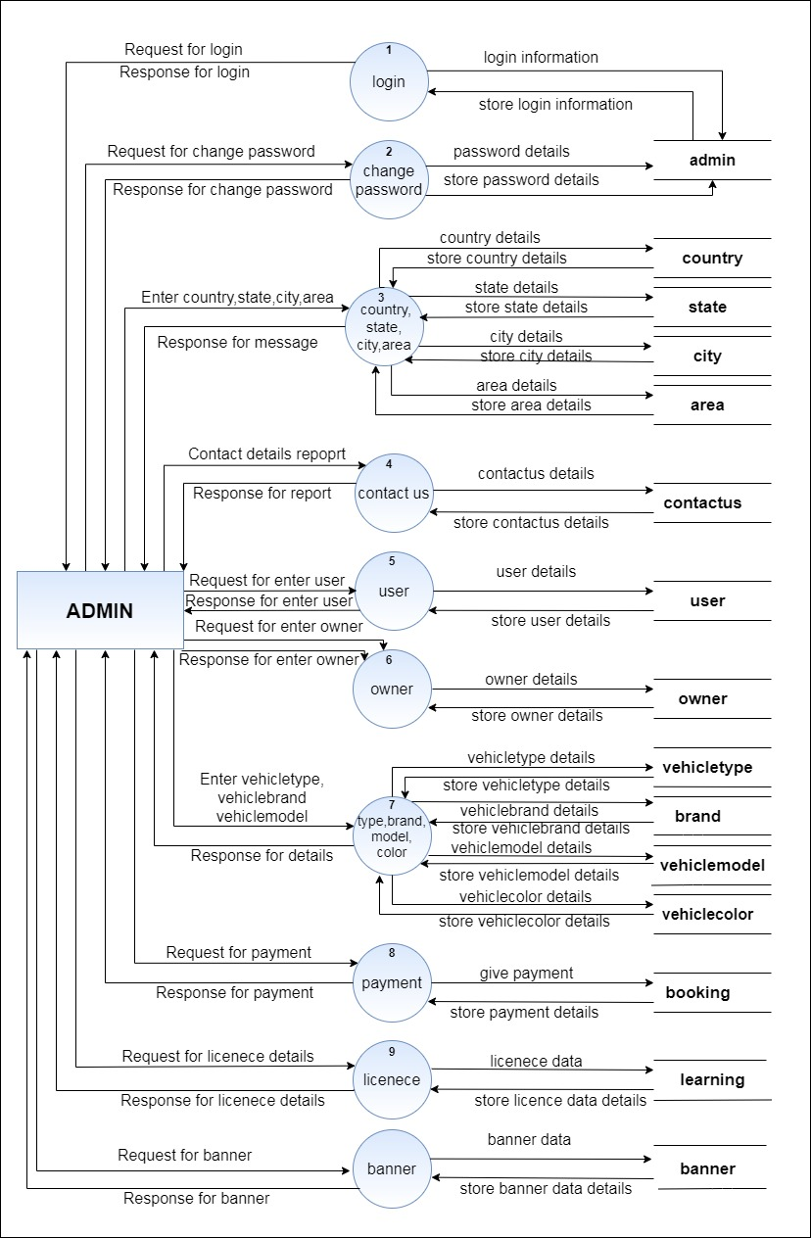

**1st Level DFD for owner**

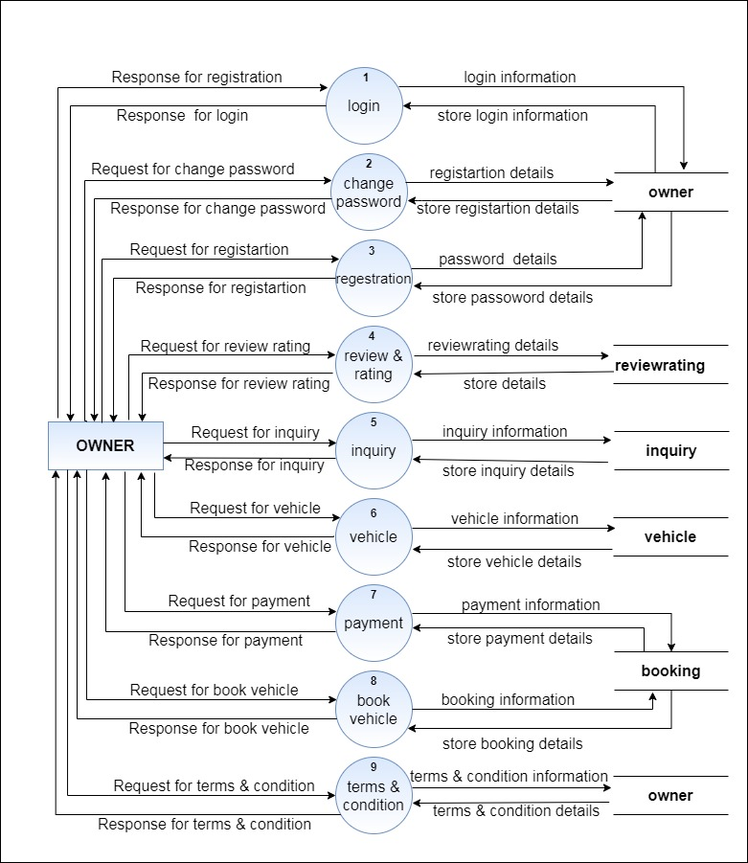

**1st Level DFD for user**

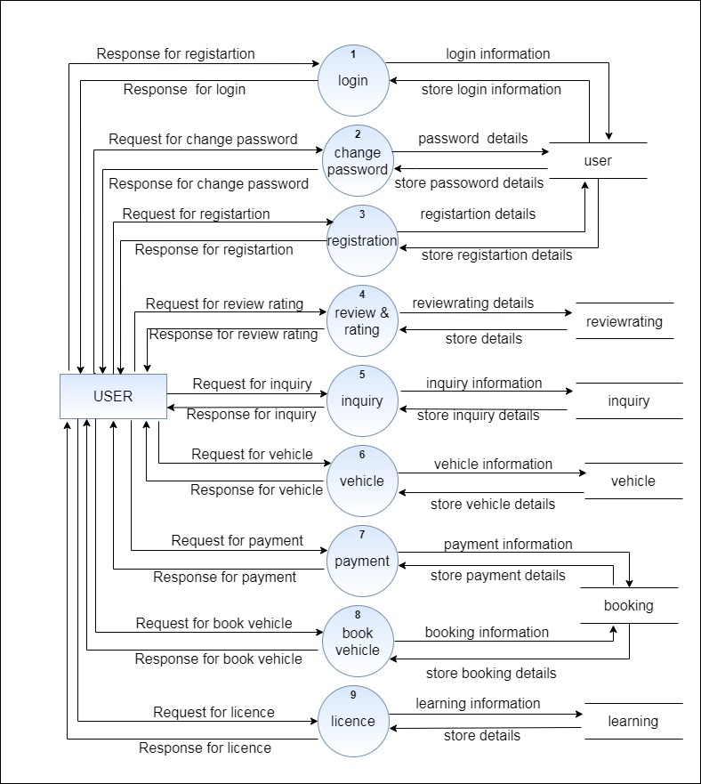

**q**

**2nd Level DFD for change password admin,owner and user side**

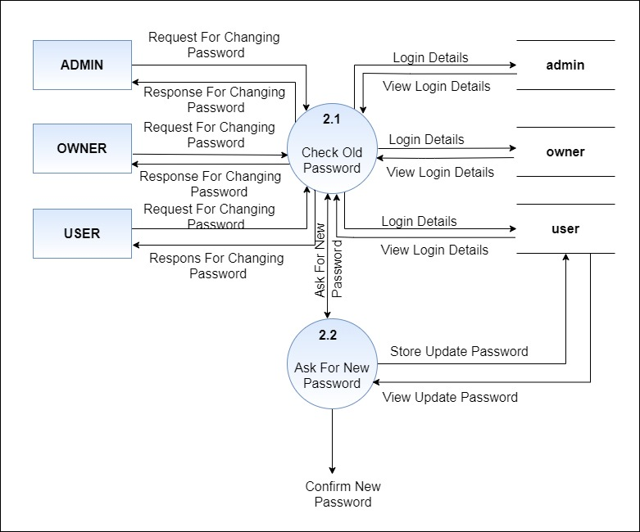

**2nd Level DFD for manage vehicle**

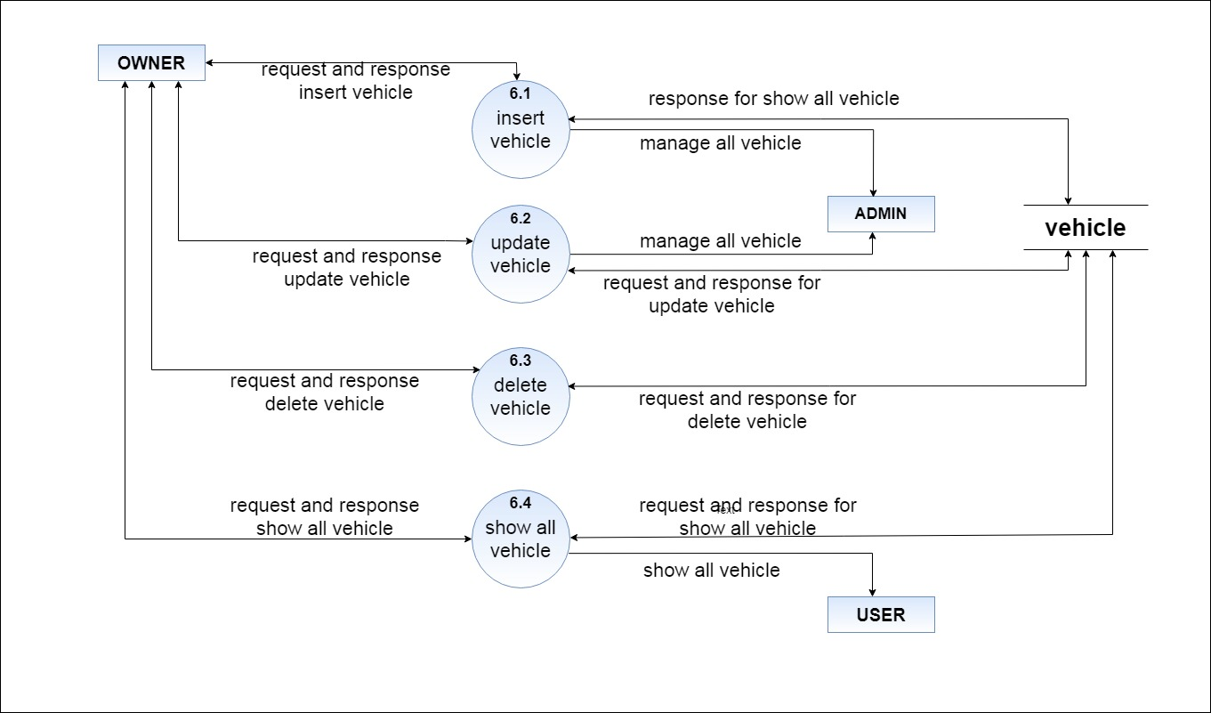

**5.2 Process Specification**

**1. Login**

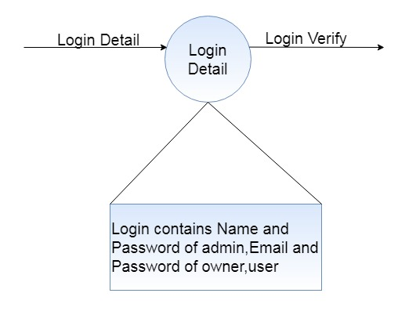

**2. Registration**

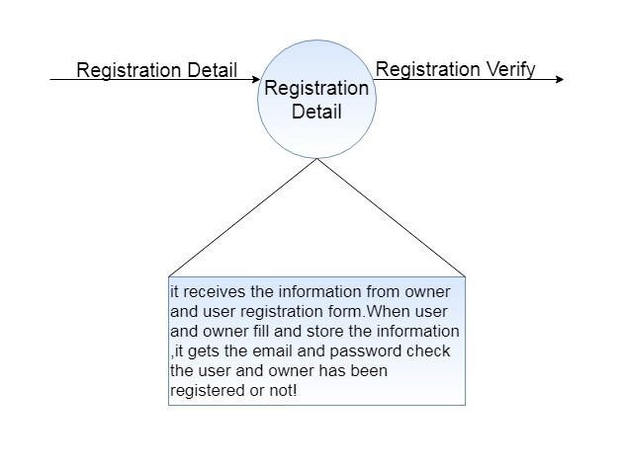

**3. Contact Us**

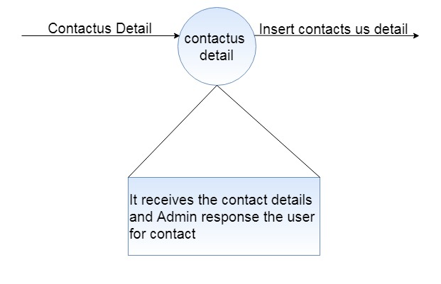

**4. Manage Vehicle**

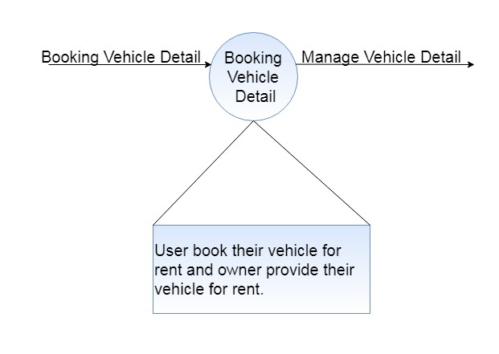

**5. Inquiry**

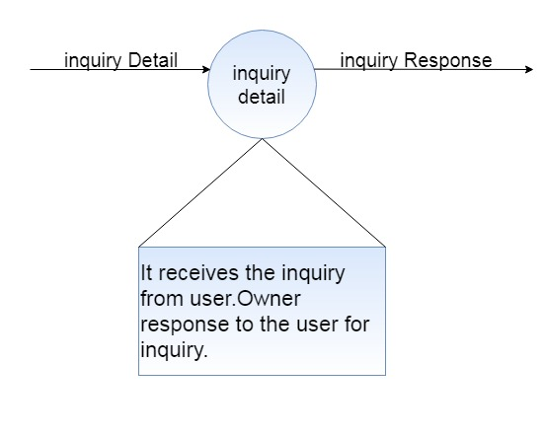

**6. Vehicle**



**5.3 Data Dictionary**

🡪Data Dictionary is repository that contains description of all data objects consumed by software.

🡪 Data Dictionary is a list of names used by the system arranged alphabetically.

🡪As well as the name, the dictionary should include a description of the named entity and if the name.

🡪 Represent of a composite object, there may be description of the composition.

**1) admin**

|  |  |
| --- | --- |
| **Field** | adminid |
| **Alias** | None |
| **Where to use** | For admin login. |
| **How to use** | For Input Process |
| **Description** | This table stores all the details. |

**2) country**

|  |  |
| --- | --- |
| **Field** | countryid |
| **Alias** | None |
| **Where to use** | Registration of owner and user input process. |
| **How to use** | For input process. |
| **Description** | This table can be storing the all details of the country. |

|  |  |
| --- | --- |
| **Field** | stateid |
| **Alias** | None |
| **Where to use** | Registration of owner and user input process. |
| **How to use** | For input process. |
| **Description** | The state will be selected from the country where this table is stored. |

**3) state**

**4) city**

|  |  |
| --- | --- |
| **Field** | cityid |
| **Alias** | None |
| **Where to use** | Registration of owner and user input process. |
| **How to use** | For input process. |
| **Description** | The city will be selected from the state where this table is stored. |

|  |  |
| --- | --- |
| **Field** | areaid |
| **Alias** | None |
| **Where to use** | Registration of owner and user input process. |
| **How to use** | For input process. |
| **Description** | The area will be selected from the city where this table is stored. |

**5) area**

**6) contactus**

|  |  |
| --- | --- |
| **Field** | contactid |
| **Alias** | None |
| **Where to use** | Store the details of communication between the admin and user. |
| **How to use** | For input process. |
| **Description** | This table can be storing the contactus details. |

**7) banner**

|  |  |
| --- | --- |
| **Field** | bannerid |
| **Alias** | None |
| **Where to use** | Store the show banners details of user. |
| **How to use** | For input and output process. |
| **Description** | This table can be storing the bannerid and path. |

**8) vehicle**

|  |  |
| --- | --- |
| **Field** | vehicleid |
| **Alias** | None |
| **Where to use** | Store the details of the car and bike. |
| **How to use** | For input process. |
| **Description** | This table can be stored the data of car and bike details. |

**9) vehicletype**

|  |  |
| --- | --- |
| **Field** | vehicletypeid |
| **Alias** | None |
| **Where to use** | Store the details of vehicle type. |
| **How to use** | For input process. |
| **Description** | The vehicle type will be selected from the vehicle type where this table can be stored. |

**10) brand**

|  |  |
| --- | --- |
| **Field** | brandid |
| **Alias** | None |
| **Where to use** | Store the details of vehicle brand. |
| **How to use** | For input process. |
| **Description** | The vehicle model will be selected from the vehicle model where this table can be stored. |

**11) vehiclemodel**

|  |  |
| --- | --- |
| **Field** | Vehiclemodelid |
| **Alias** | None |
| **Where to use** | Store the details of vehicle model. |
| **How to use** | For input process. |
| **Description** | The brand will be selected from brand where this table can be stored. |

**12) vehiclecolor**

|  |  |
| --- | --- |
| **Field** | colorid |
| **Alias** | None |
| **Where to use** | Store the details of vehicle color. |
| **How to use** | For input process. |
| **Description** | This table can be storing the color of vehicle details. |

**13) owner**

|  |  |
| --- | --- |
| **Field** | ownerid |
| **Alias** | None |
| **Where to use** | For owner edit profile and login. |
| **How to use** | For input process. |
| **Description** | This table can be storing all the registration details of owner. |

**14) reviewrating**

|  |  |
| --- | --- |
| **Field** | rrid |
| **Alias** | None |
| **Where to use** | Store the details of the reviewrating who gives from user. |
| **How to use** | For input process. |
| **Description** | This table can be storing the reviewrating details. |

**15) inquiry**

|  |  |
| --- | --- |
| **Field** | inquiryid |
| **Alias** | None |
| **Where to use** | Store the details of communication between the owner and user. |
| **How to use** | For input process. |
| **Description** | This table can be storing the inquiry details. |

**16) user**

|  |  |
| --- | --- |
| **Field** | userid |
| **Alias** | None |
| **Where to use** | For user edit profile and login. |
| **How to use** | For input process. |
| **Description** | This table can be storing all the registration details of user. |

**17) booking**

|  |  |
| --- | --- |
| **Field** | bookingid |
| **Alias** | None |
| **Where to use** | Store the details of car and bike booking for the user. |
| **How to use** | For input process. |
| **Description** | This table can be storing the car and bike booking details. |

**18) album**

|  |  |
| --- | --- |
| **Field** | albumid |
| **Alias** | None |
| **Where to use** | Store the car and bike album details. |
| **How to use** | For input process. |
| **Description** | This table can be storing the car and bike album details. |

**19) learning**

|  |  |
| --- | --- |
| **Field** | learningid |
| **Alias** | None |
| **Where to use** | Store the details of the user who fill up the learning license form. |
| **How to use** | For input process. |
| **Description** | This table can be storing the learning license user details. |

**5.4 ER Diagram**

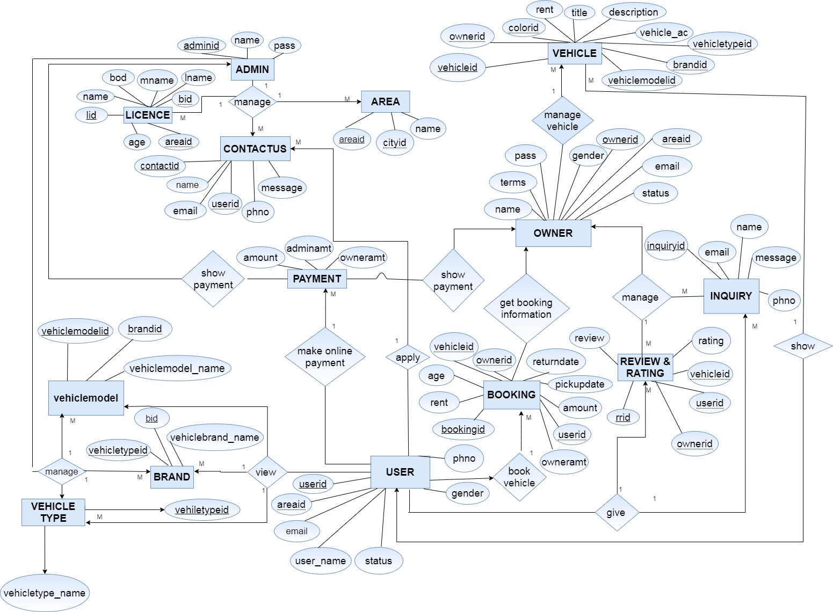

**6.1 Database Design**

**6.2 Directory Structure**

**6.3 Input Design**

**6.4 Output Design**

**6.1 Database Design**

**1. admin**

|  |  |  |  |
| --- | --- | --- | --- |
| **Field name** | **datatype** | **constraints** | **Description** |
| adminid | Int | Primary key | It indicates Unique id of admin. |
| name | Varchar(50) | Not null | It indicates Name of admin. |
| pass | Varchar(40) | Not null | It indicates Password of admin. |

**2.banner**

|  |  |  |  |
| --- | --- | --- | --- |
| **Field name** | **datatype** | **constraints** | **Description** |
| bannerid | Int | Primary key | It indicates Unique id of banner. |
| path | text | Not null | It indicates Path of banner. |

**3.contactus**

|  |  |  |  |
| --- | --- | --- | --- |
| **Field name** | **Datatype** | **constraints** | **Description** |
| contactid | Int | Primary key | It indicates Unique id of contact us. |
| name | Varchar(50) | Not null | It indicates Name of contact us. |
| email | Varchar(255) | Not null | It indicates Email of contact us. |
| subject | Varchar(50) | Not null | It indicates subject of contact us. |
| message | Text | Not null | It indicates Description of contact us. |

**4.owner**

|  |  |  |  |
| --- | --- | --- | --- |
| **Field name** | **datatype** | **constraints** | **Description** |
| ownerid | Int | Primary key | It indicates Unique id of owner. |
| profilepic | Varchar(20) | null | It indicates Profile pic of owner. |
| areaid | Int | foreign key | It indicates References id of user. |
| owner_name | Varchar(50) | Not null | It indicates Name of owner. |
| owner_email | Varchar(255) | Not null | It indicates Email of owner. |
| pass | Varchar(40) | Not null | It indicates Password of owner. |
| owner_phno | Bigint(13) | Not null | It indicates Phone number of owner. |
| gender | Varchar(7) | Not null | It indicates Gender of owner. |
| address | Varchar(50) | Not null | It indicates Address of owner. |
| location | Text | Null | It indicates Location of owner car and bike. |
| terms | Text | Not null | It indicates Terms of owner vehicle. |
| createdate | DateTime | Not null | It indicates Create date of owner login. |
| Status | Varchar(10) | Not null | It indicates Status of owner login. |

**5.reviewrating**

|  |  |  |  |
| --- | --- | --- | --- |
| **Field name** | **datatype** | **constraints** | **Description** |
| rrid | Int | Primary key | It indicates Unique id of review rating. |
| userid | Int | foreign key | It indicates References id of user. |
| vehicleid | Int | foreign key | It indicates References id of vehicle. |
| rating | Int | Not Null | It indicates Rate of vehicle. |
| review | Text | Not Null | It indicates Review of vehicle. |
| createdate | DateTime | Not Null | It indicates create date of review rating. |

**6. inquiry**

|  |  |  |  |
| --- | --- | --- | --- |
| **Field name** | **datatype** | **constraints** | **Description** |
| inquiryid | Int | Primary key | It indicates Unique id of inquiry. |
| vehicleid | Int | foreign key | It indicates Reference id of vehicle. |
| userid | Int | foreign key | It indicates Reference id of user. |
| subject | Varchar(50) | Not null | It indicates subject of inquiry. |
| message | Text | Not null | It indicates Description of inquiry. |
| createdate | DateTime | Not null | It indicates Description of createdate. |
| inquiry_status | Varchar(10) | Not null | It indicates status of inquiry. |

**7.user**

|  |  |  |  |
| --- | --- | --- | --- |
| **Field name** | **datatype** | **constraints** | **Description** |
| userid | Int | Primary key | It indicates Unique id of user. |
| profilepic | Text | Not null | It indicates Profile pic of user. |
| areaid | Int | foreign key | It indicates References id of area. |
| user_name | Varchar(50) | Not null | It indicates Name of admin. |
| email | Varchar(255) | Not null | It indicates Email of user. |
| pass | Varchar(40) | Not null | It indicates Password of user. |
| phno | bigInt(13) | Not null | It indicates Ph.No of user. |
| gender | Varchar(7) | Not null | It indicates Gender of user. |
| address | Varchar(50) | Not null | It indicates Address of user. |
| createdate | DateTime | Not null | It indicates Create date of user registration. |
| status | Varchar(10) | Not null | It indicates Status of user |

**8.booking**

|  |  |  |  |
| --- | --- | --- | --- |
| **Field name** | **datatype** | **constraints** | **Description** |
| bookingid | Int | Primary key | It indicates Unique id of booking. |
| ownerid | Int | Foreign key | It indicates References id of owner. |
| userid | Int | Foreign key | It indicates References id of user. |
| vehicleid | Int | Foreign key | It indicates References id of vehicle. |
| age | Int(2) | Not null | It indicates Age of user. |
| rent | Int(6) | Not null | It indicates Rent of vehicle. |
| nod | Bigint(2) | Not null | It indicates Total number of vehicle rent day. |
| pickup_date | TimeStamp | Not null | It indicates Pickup date of vehicle. |
| return_date | TimeStamp | null | It indicates Return date of vehicle. |
| amount | Int | Not null | It indicates Amount of total vehicle. |
| owneramt | Int(5) | Not null | It indicates Amount of owner. |
| adminamt | Int(5) | Not null | It indicates Amount of admin. |
| createdate | Date | Not null | It indicates created date of booking. |
| booking_status | Int(3) | Not null | It indicates status of booking. |

**9.country**

|  |  |  |  |
| --- | --- | --- | --- |
| **Field name** | **datatype** | **constraints** | **Description** |
| countryid | Int | Primary key | It indicates Unique id of country. |
| name | Varchar(50) | Not null | It indicates Name of country. |

**10.state**

|  |  |  |  |
| --- | --- | --- | --- |
| **Field name** | **datatype** | **constraints** | **Description** |
| stateid | Int | Primary key | It indicates Unique id of state. |
| countryid | Int | Foreign key | It indicates References id of country. |
| name | Varchar(50) | Not null | It indicates Name of state. |

**11.city**

|  |  |  |  |
| --- | --- | --- | --- |
| **Field name** | **datatype** | **constraints** | **Description** |
| cityid | Int | Primary key | It indicates Unique id of city. |
| stateid | Int | Foreign key | It indicates References id of state. |
| city_name | Varchar(50) | Not null | It indicates Name of city. |

**12.area**

|  |  |  |  |
| --- | --- | --- | --- |
| **Field name** | **datatype** | **constraints** | **Description** |
| areaid | Int | Primary key | It indicates Unique id of area. |
| cityid | Int | Foreign key | It indicates References id of city. |
| area_name | Varchar(50) | Not null | It indicates Name of area. |

**13.vehicle**

|  |  |  |  |
| --- | --- | --- | --- |
| **Field name** | **datatype** | **constraints** | **Description** |
| vehicleid | Int | Primary key | It indicates Unique id of vehicle. |
| ownerid | Int | Foreign key | It indicates References id of owner. |
| vehiclemodelid | Int | Foreign key | It indicates References id of vehicle model. |
| brandid | Int | Foreign key | It indicates References id of brand. |
| seater | Int(2) | Null | It indicates total seat of vehicle. |
| vehicletypeid | Int | Foreign key | It indicates References id of vehicletype. |
| colorid | Int(3) | Foreign key | It indicates References id of color. |
| vehicle_ac | Varchar(10) | Not null | It indicates Ac or non-ac of vehicle. |
| title | Varchar(50) | Not null | It indicates Title of vehicle. |
| rent | Int(6) | Not null | It indicates Rent of vehicle. |
| description | Text | Not null | It indicates Description of vehicle. |
| detail | Text | Not null | It indicates details of vehicle. |

**14.vehicletype**

|  |  |  |  |
| --- | --- | --- | --- |
| **Field name** | **Datatype** | **constraints** | **Description** |
| vehicletypeid | Int | Primary key | It indicates Unique id of vehicle. |
| vehicletype_name | Varchar(50) | Not null | It indicates Name of vehicle. |

**15.brand**

|  |  |  |  |
| --- | --- | --- | --- |
| **Field name** | **Datatype** | **constraints** | **Description** |
| brandid | Int | Primary key | It indicates Unique id of brand. |
| vehicletypeid | Int | Foreign key | It indicates References id of vehicle type. |
| vehiclebrand_name | Varchar(50) | Not null | It indicates Name of vehicle brand. |

|  |  |  |  |
| --- | --- | --- | --- |
| **Field name** | **datatype** | **constraints** | **Description** |
| vehiclemodelid | Int | Primary key | It indicates Unique id of vehiclemodel. |
| brandid | Int | Foreign key | It indicates References id of brand. |
| vehiclemodel_name | Varchar(50) | Not null | It indicates Name of vehiclemodel. |

**16.vehiclemodel**

**17.vehiclecolor**

|  |  |  |  |
| --- | --- | --- | --- |
| **Field name** | **datatype** | **constraints** | **Description** |
| colorid | Int | Primary key | It indicates Unique id of color. |
| color_name | Varchar(10) | Not null | It indicates Name of color. |

**18.album**

|  |  |  |  |
| --- | --- | --- | --- |
| **Field name** | **datatype** | **constraints** | **Description** |
| albumid | Int | Primary key | It indicates Unique id of album. |
| vehicleid | Int | Foreign key | It indicates References id of vehicle. |
| path | Text | Not null | It indicates Path of album. |

**19.learning**

|  |  |  |  |
| --- | --- | --- | --- |
| **Field name** | **datatype** | **constraints** | **Description** |
| llid | Int | Primary key | It indicates Unique id of inquiry. |
| fname | Varchar(50) | Not null | It indicates First Name of learning user. |
| mname | Varchar(50) | Not null | It indicates middle Name of learning User. |
| lname | Varchar(50) | Not null | It indicates last Name of learning user. |
| email | Varchar(255) | Not null | It indicates Email of learning user. |
| phno | Bigint(13) | Not null | It indicates Phone number of learning user. |
| bod | Date | Not null | It indicates Birth of date. |
| age | Int(2) | Not null | It indicates Age of user. |
| areaid | Int | Foreign key | It indicates References key of area. |
| address | Varchar(50) | Not null | It indicates Address of user. |
| bloodgroup | Varchar(3) | Notnull | It indicates Blood group of user. |
| qualification | Varchar(20) | Notnull | It indicates Qualification of user. |

**6.2Directory Structure**

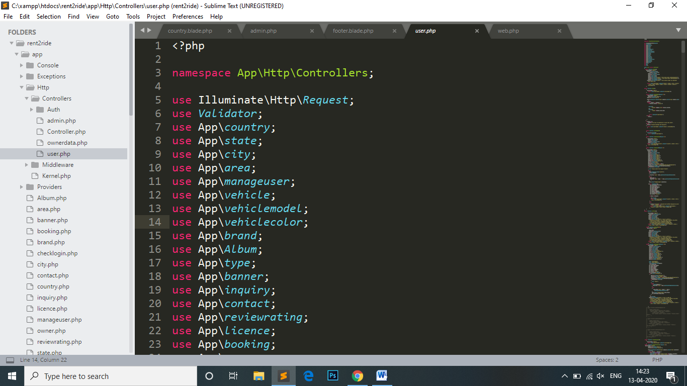

**6.3 Input Design &Output Design**

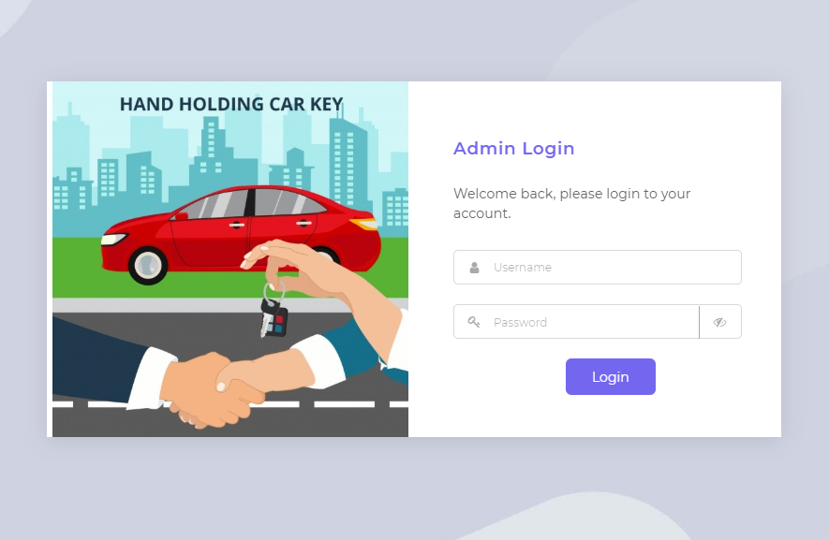

**Admin Side:**

**Login Page**

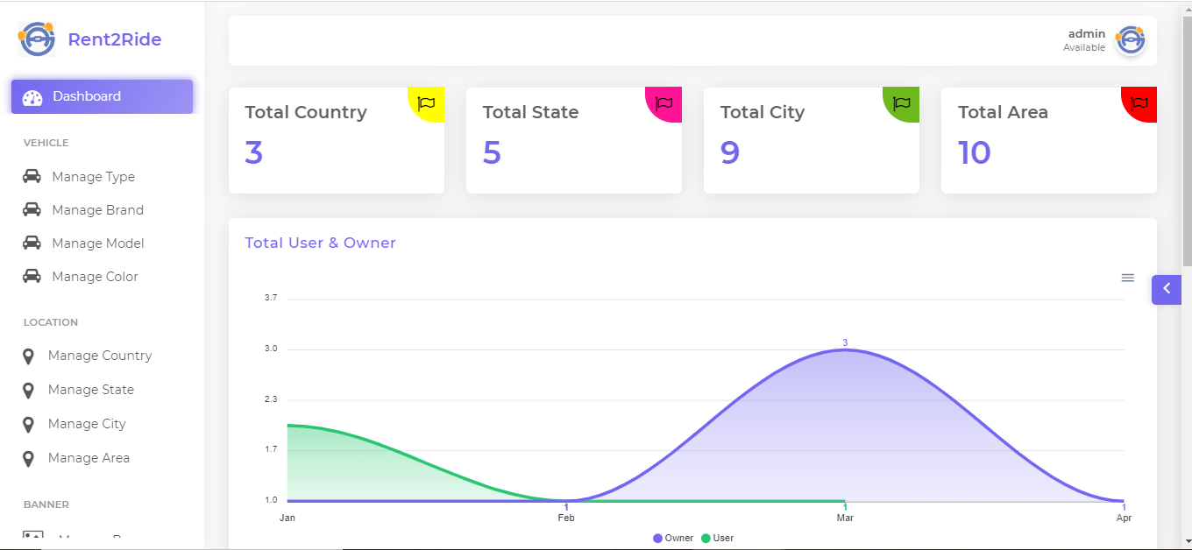**Home Page**

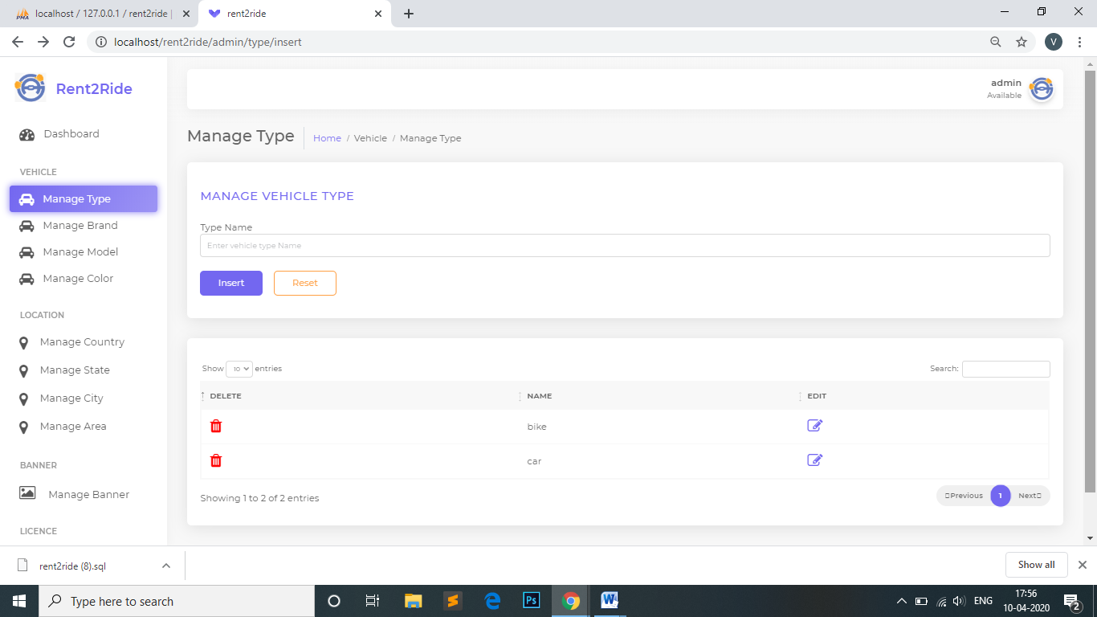**View, Insert, Update and Delete Type**

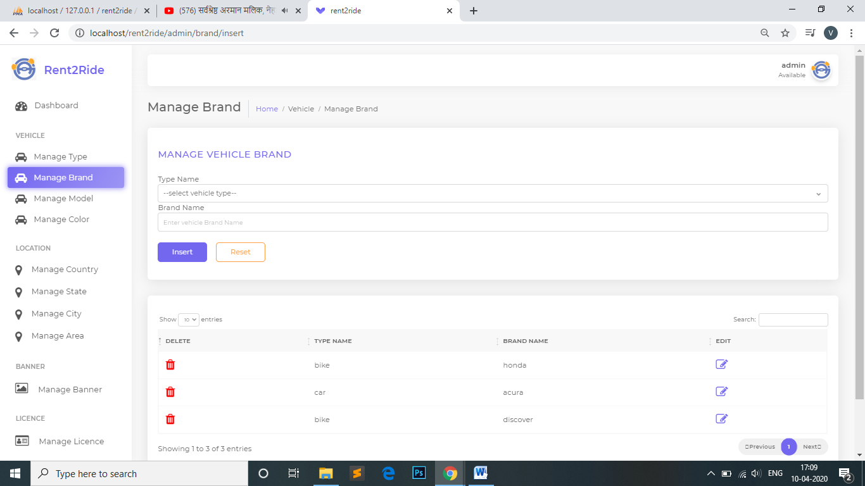**View, Insert, Update and Delete Brand**

**View, Insert, Update and Delete Model**

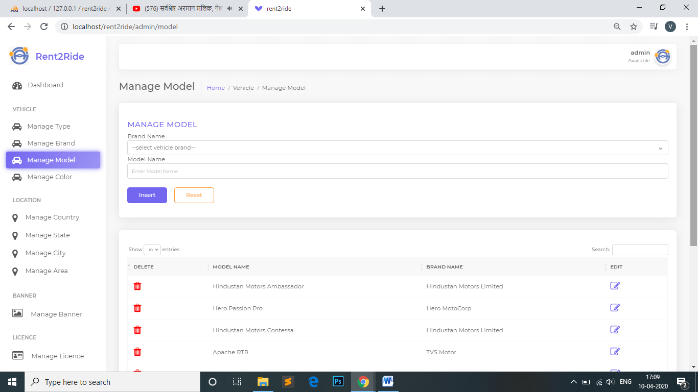

**View, Insert, Update and Delete Area**

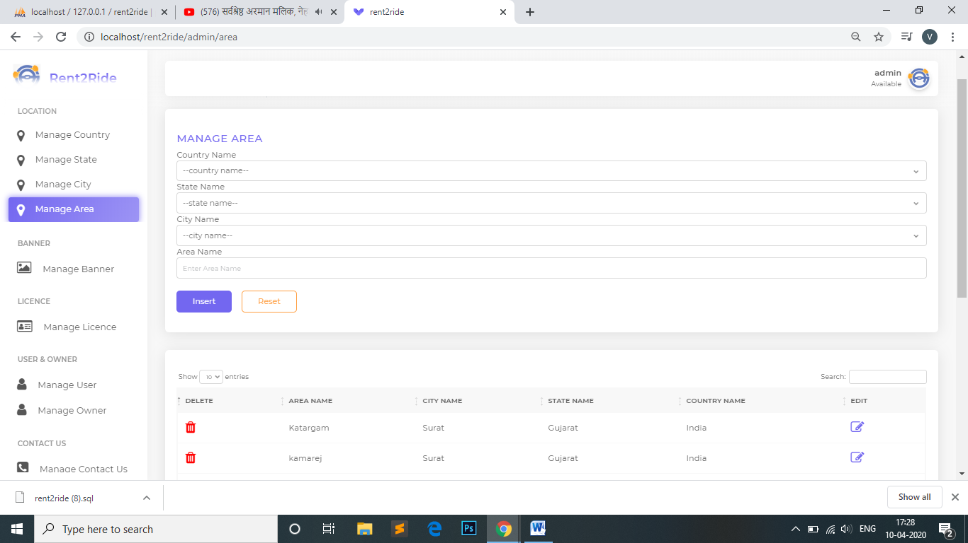

**Active and Block Registered Users**

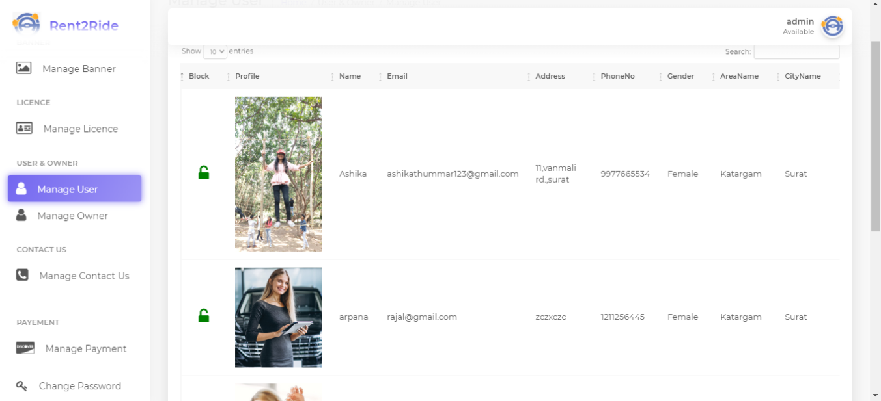

**Active and Block Registered Owner**

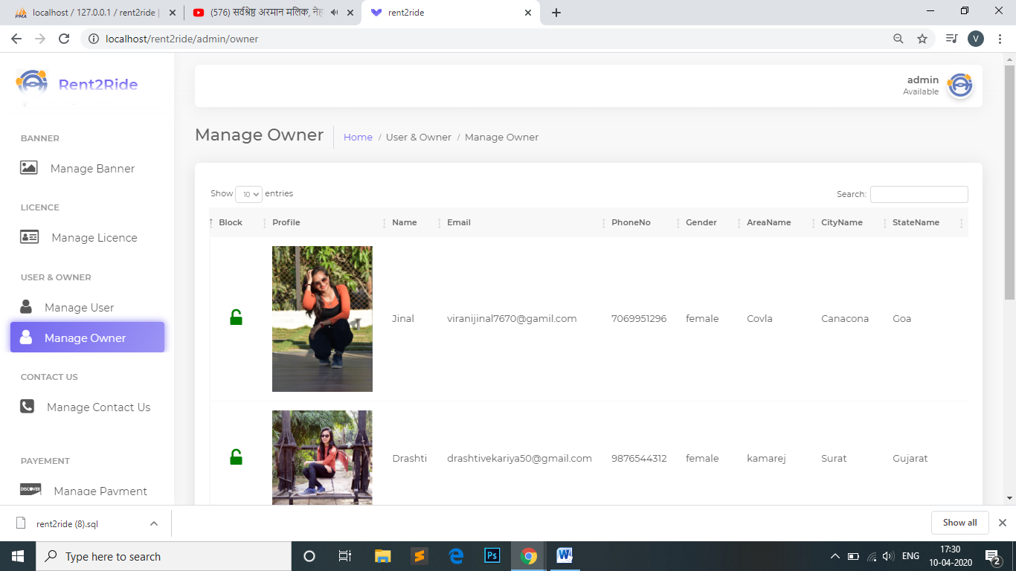

**Manage Banner**

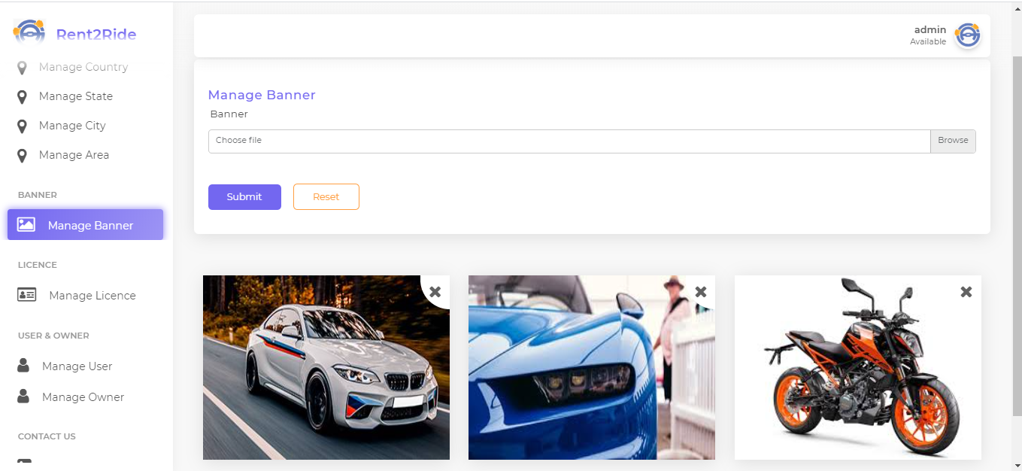

**Manage User Licence**

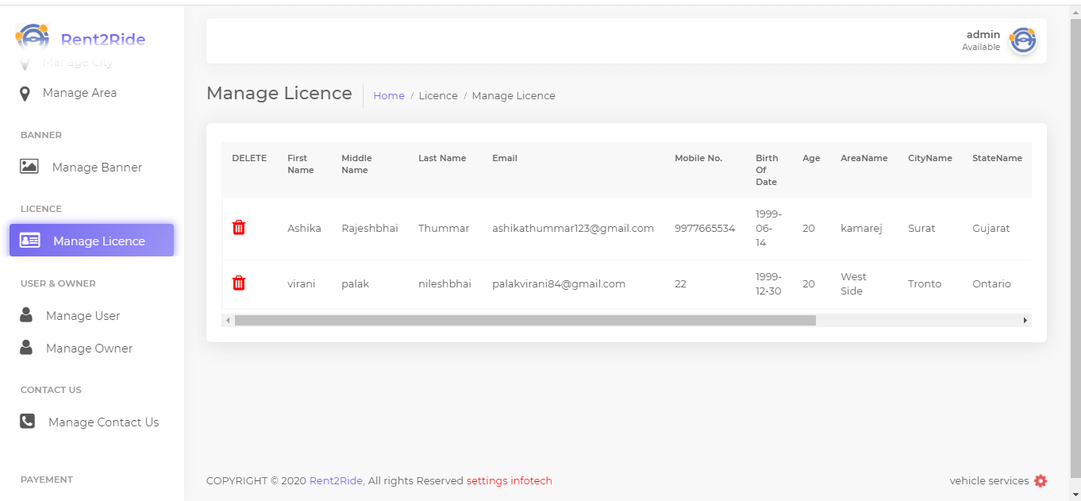

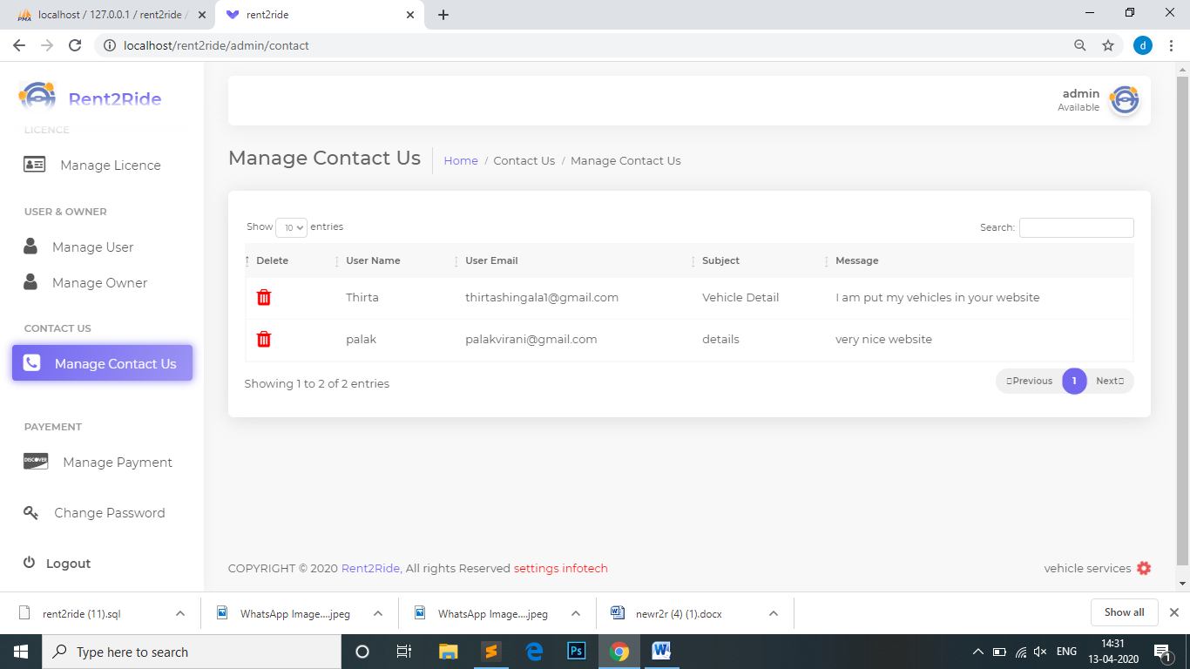**Manage Contact Us**

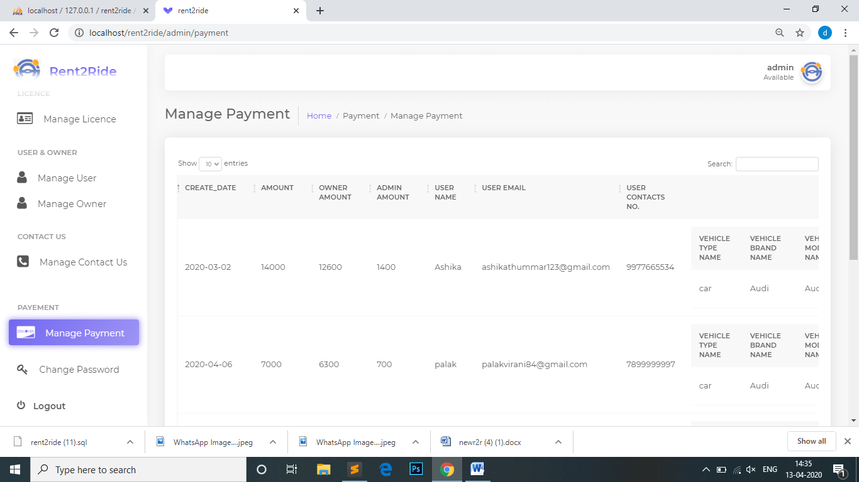**Manage Payment**

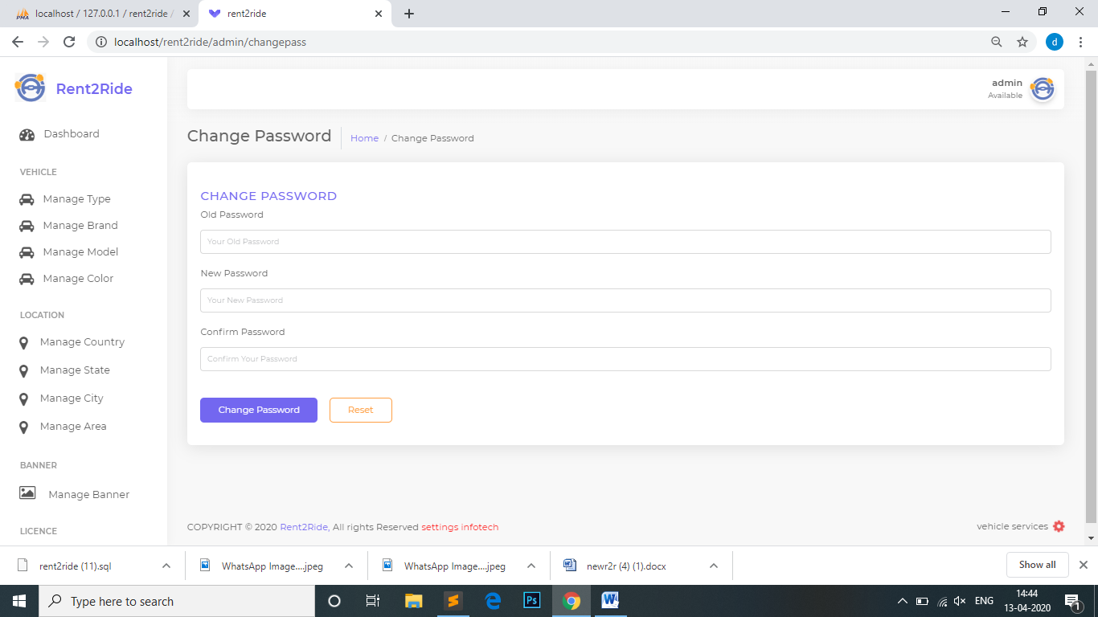 **Change Password Owner Side:**

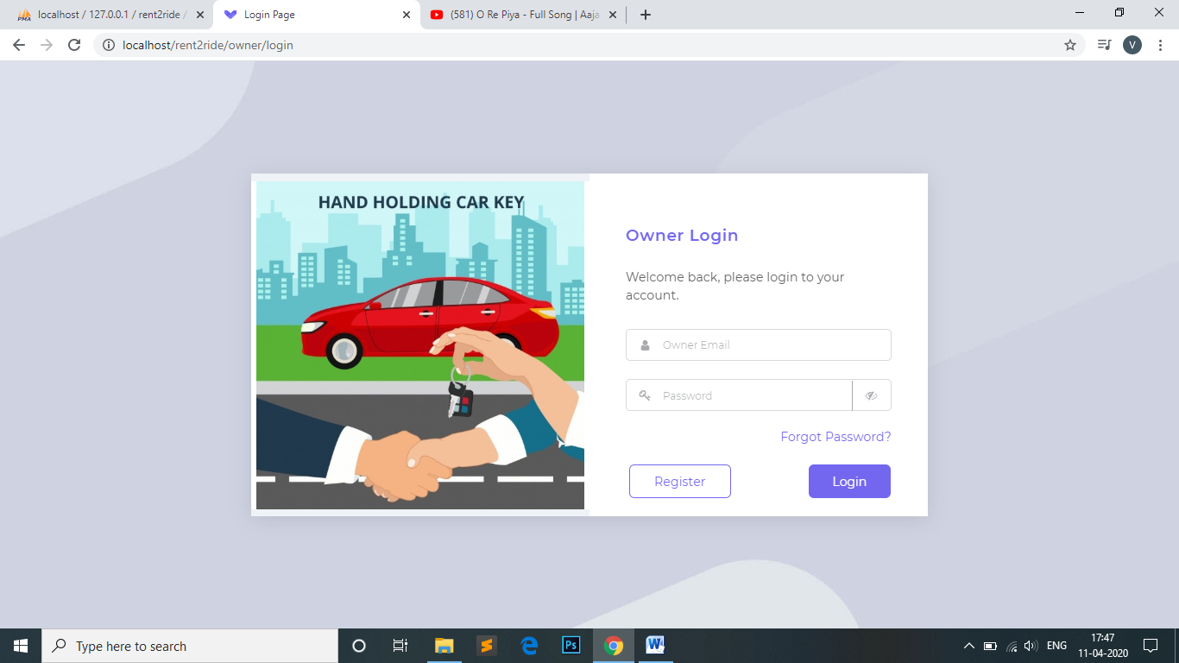**Login Page**

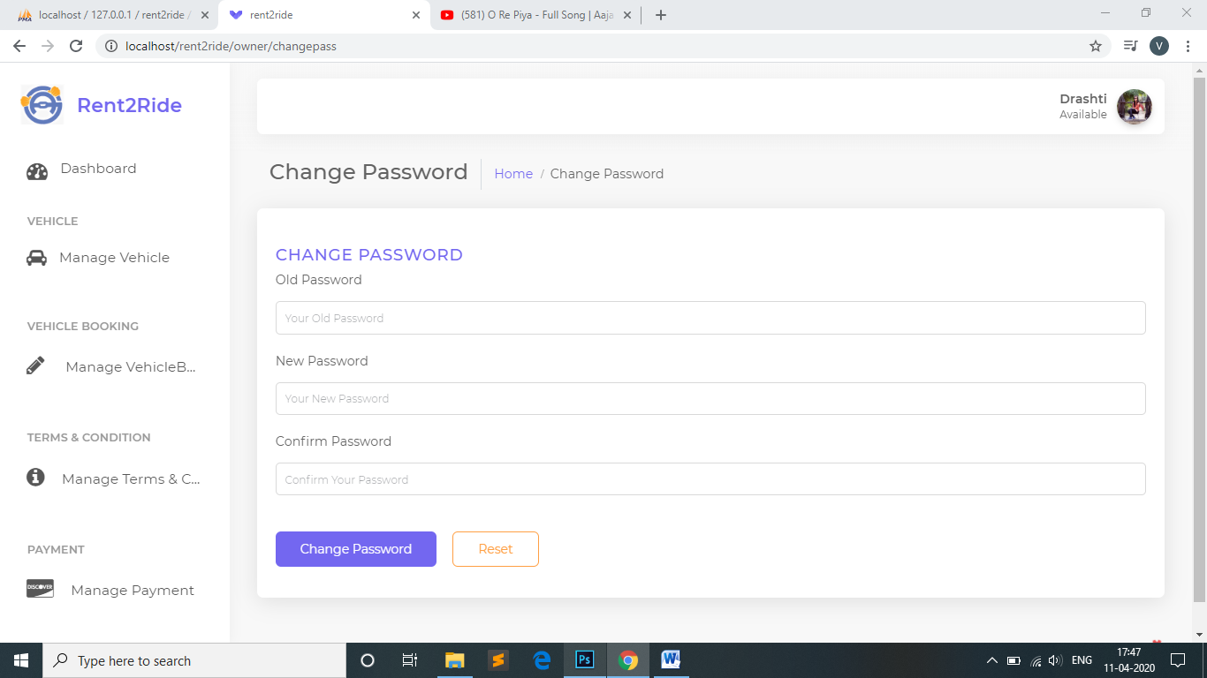**Change Password**

**Home Page**

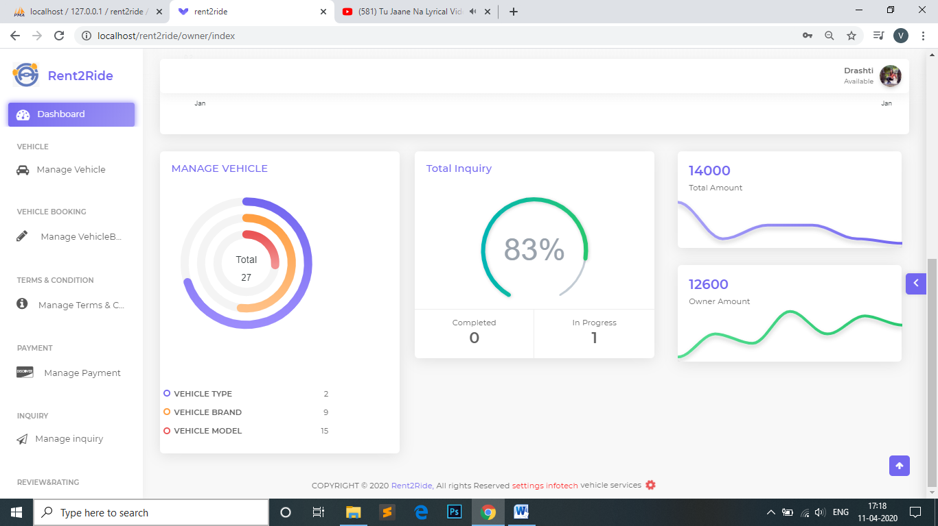

**Manage Vehicle Booking**

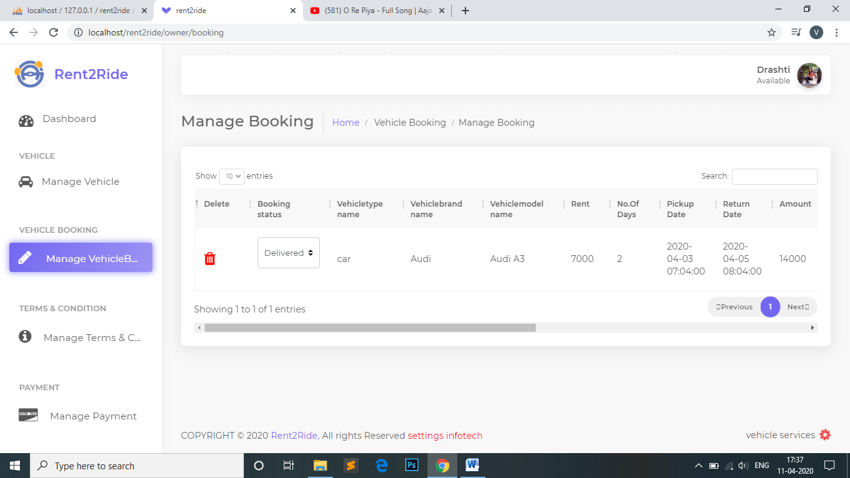

**Manage Terms/Condition**

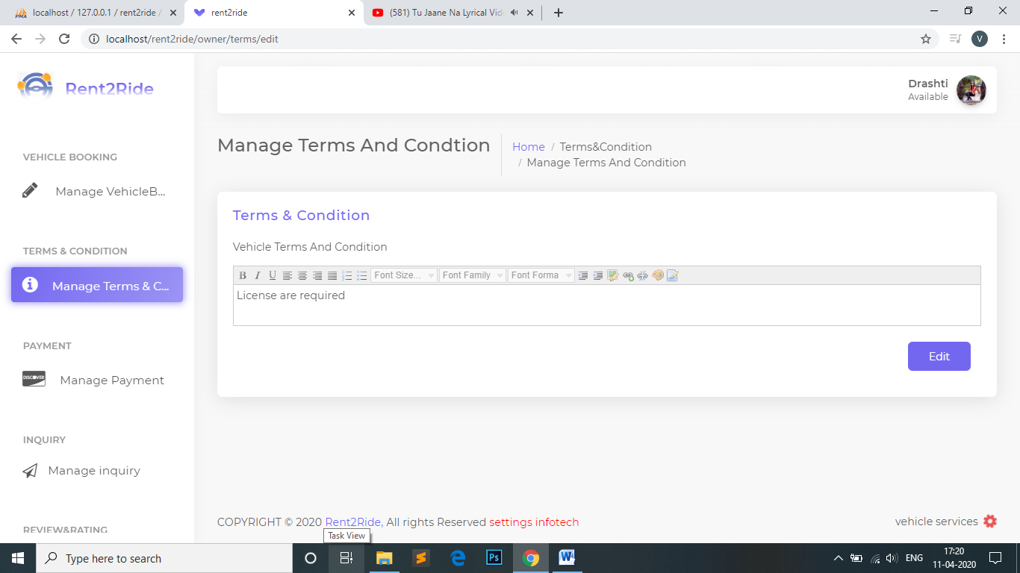

**Manage Edit Profile**

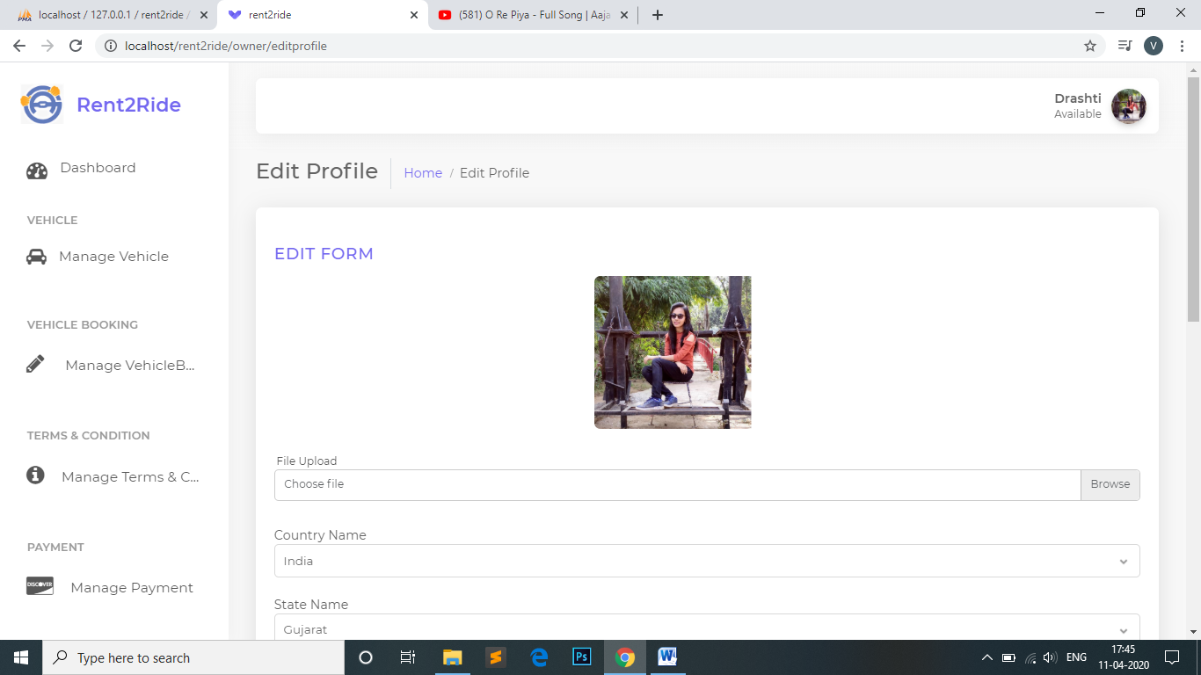

**Manage Vehicle**

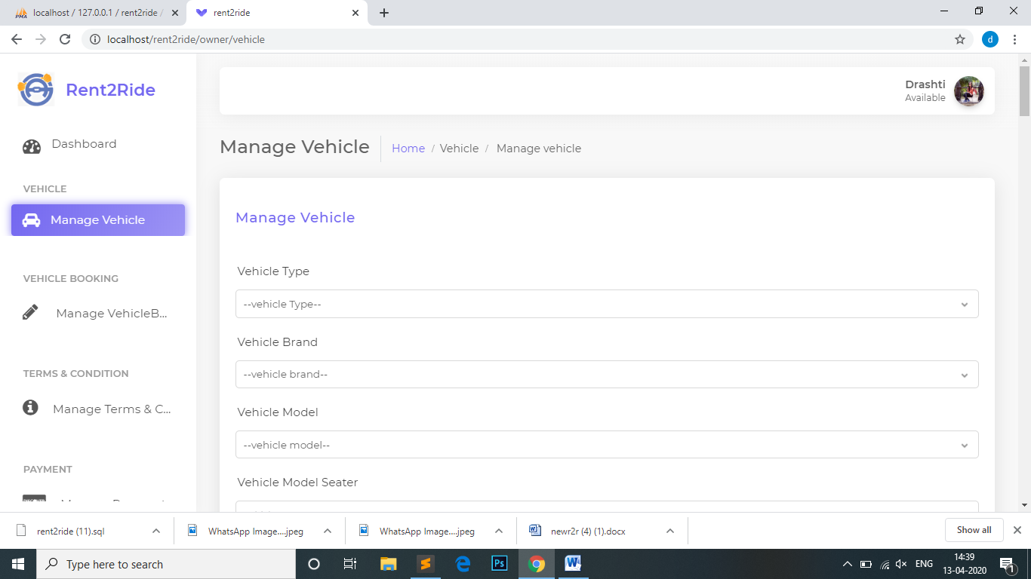

**Manage Payment**

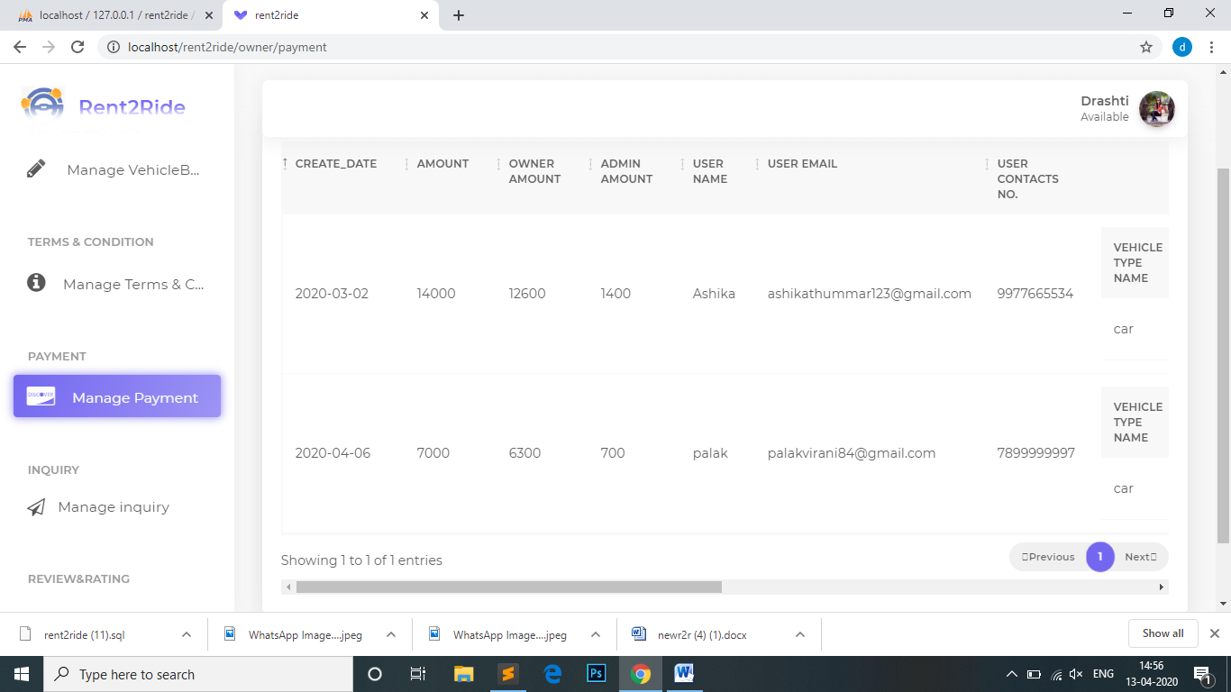

**Manage Inquiry**

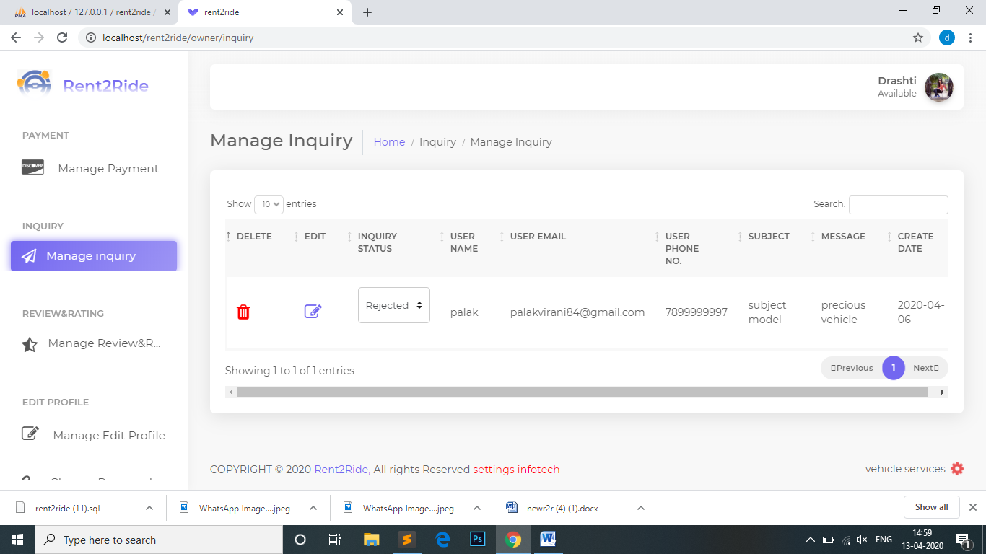

**Manage Review&Rating**

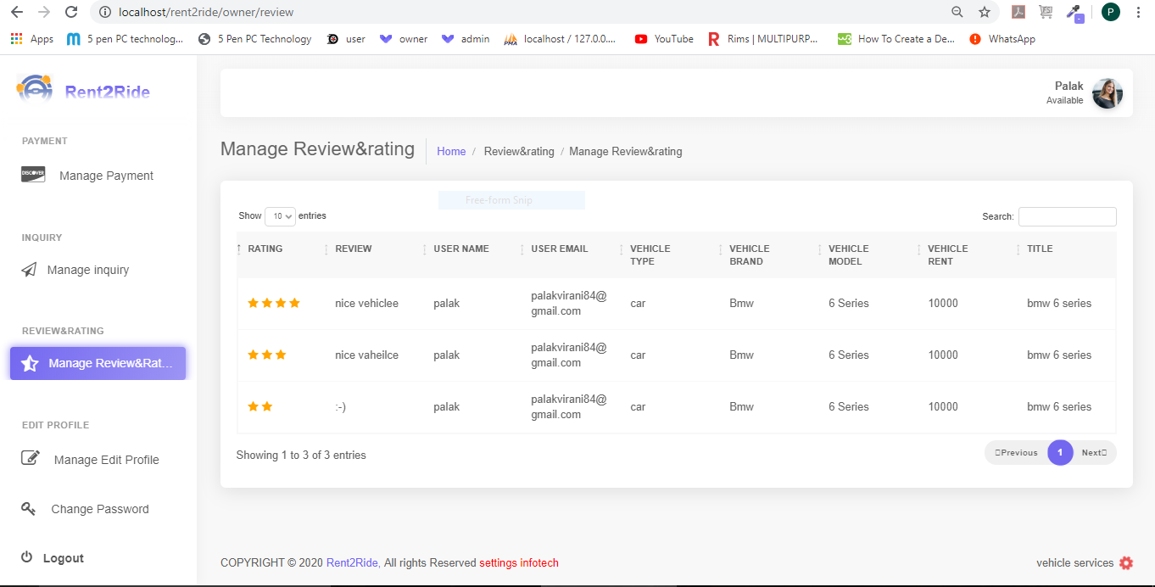

**User Side:**

**User Login**

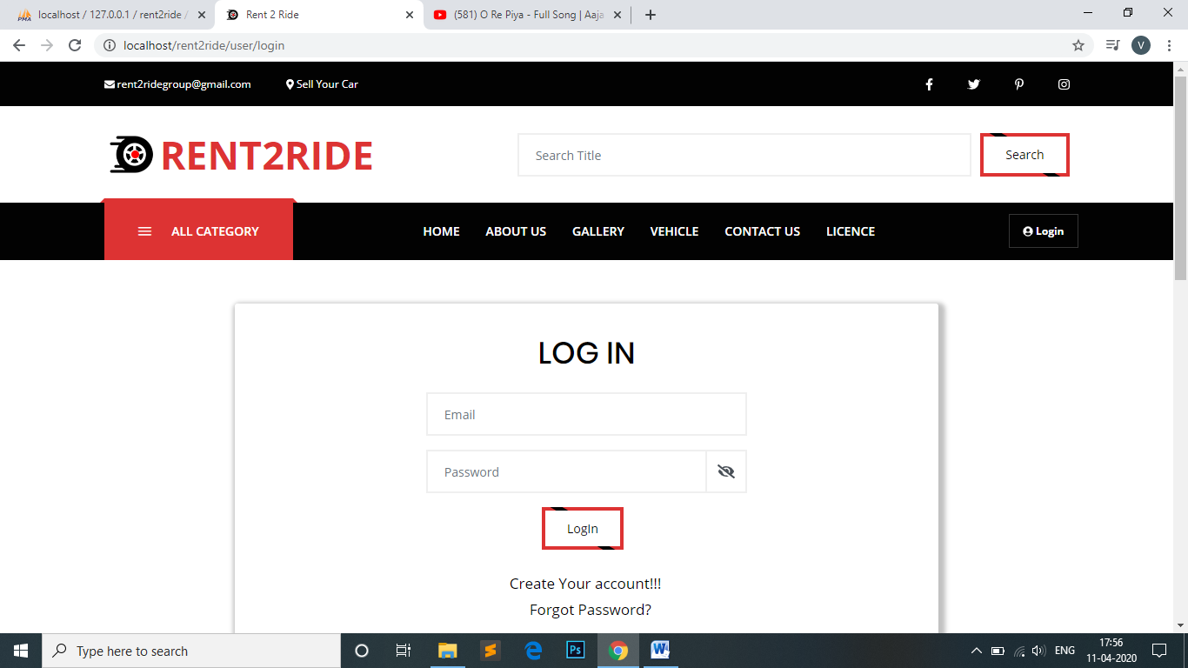

**Registration**

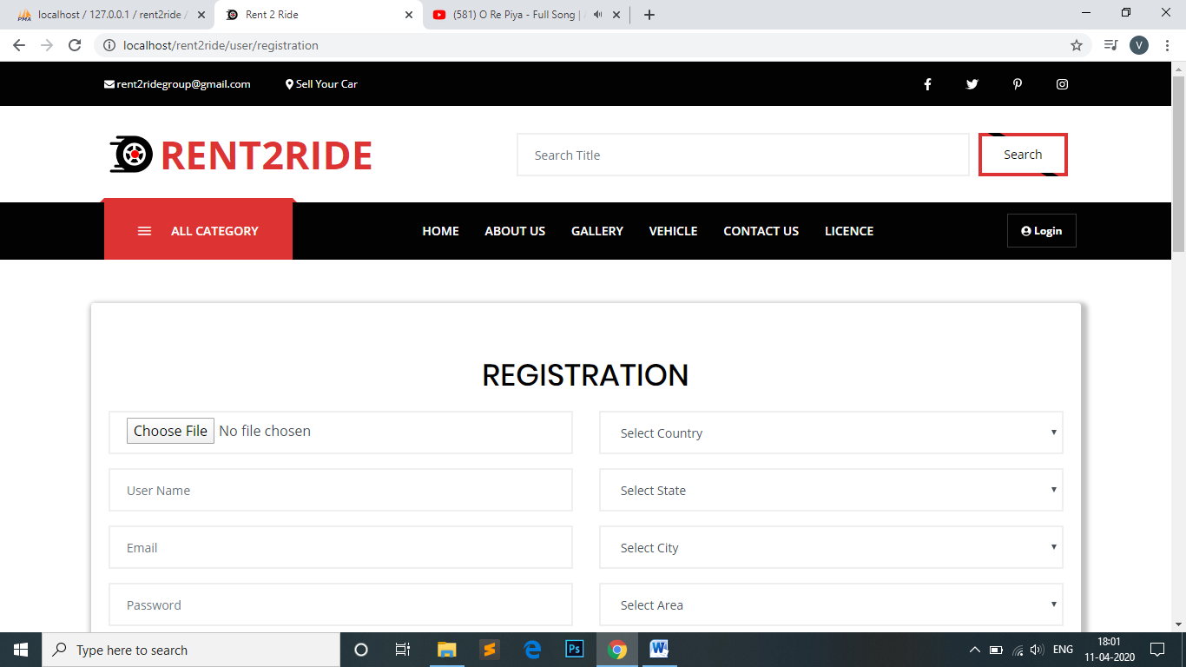

**Forgot Password**

**Change Password**

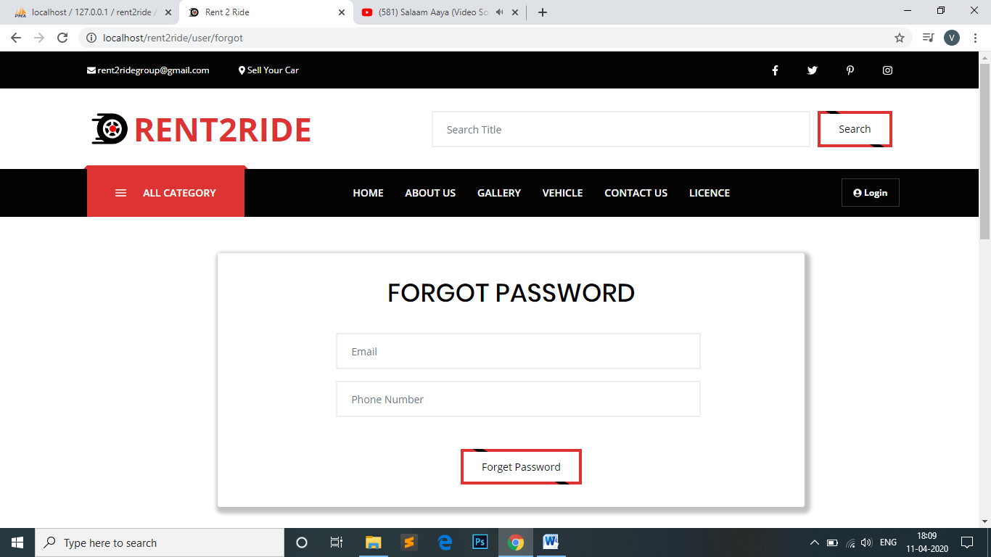

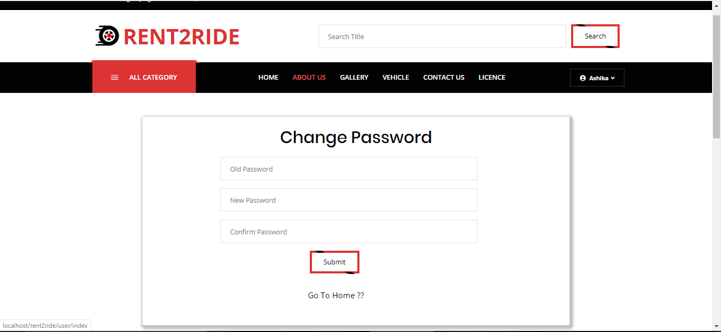

**Home Page**

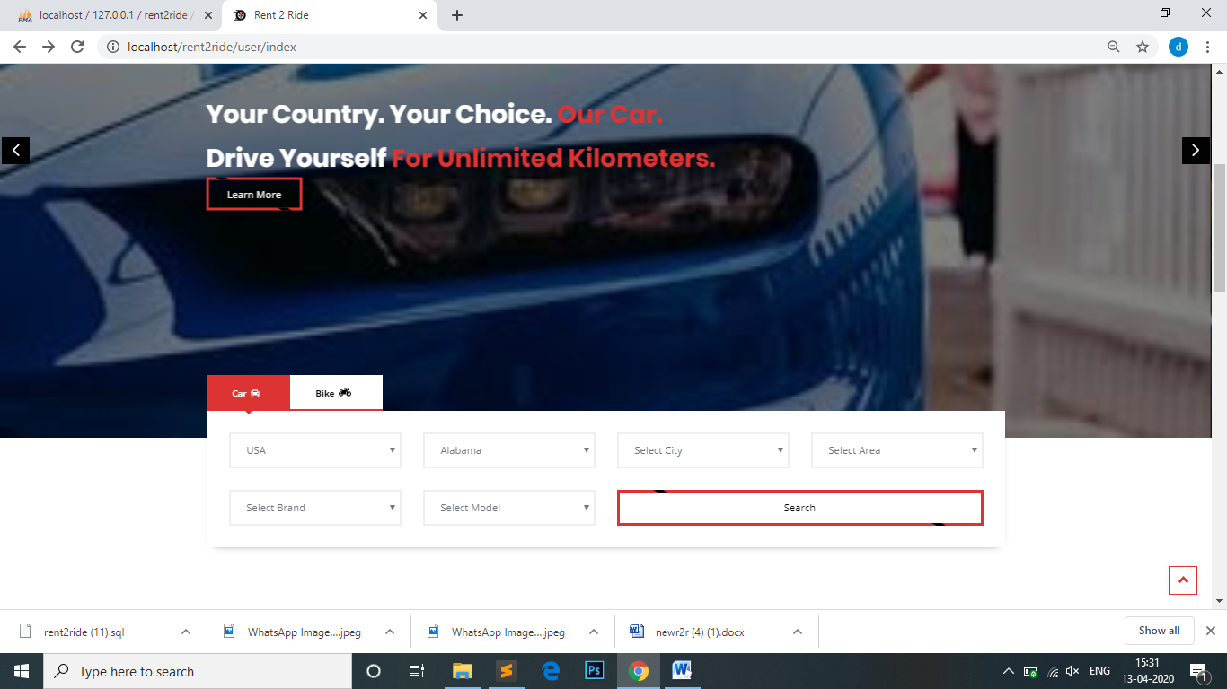

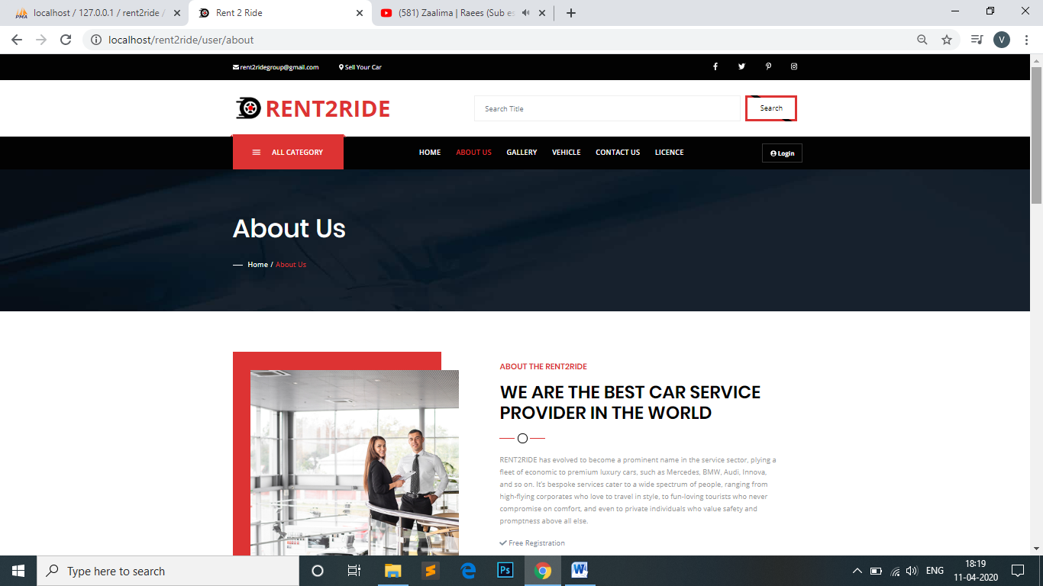**About Us**

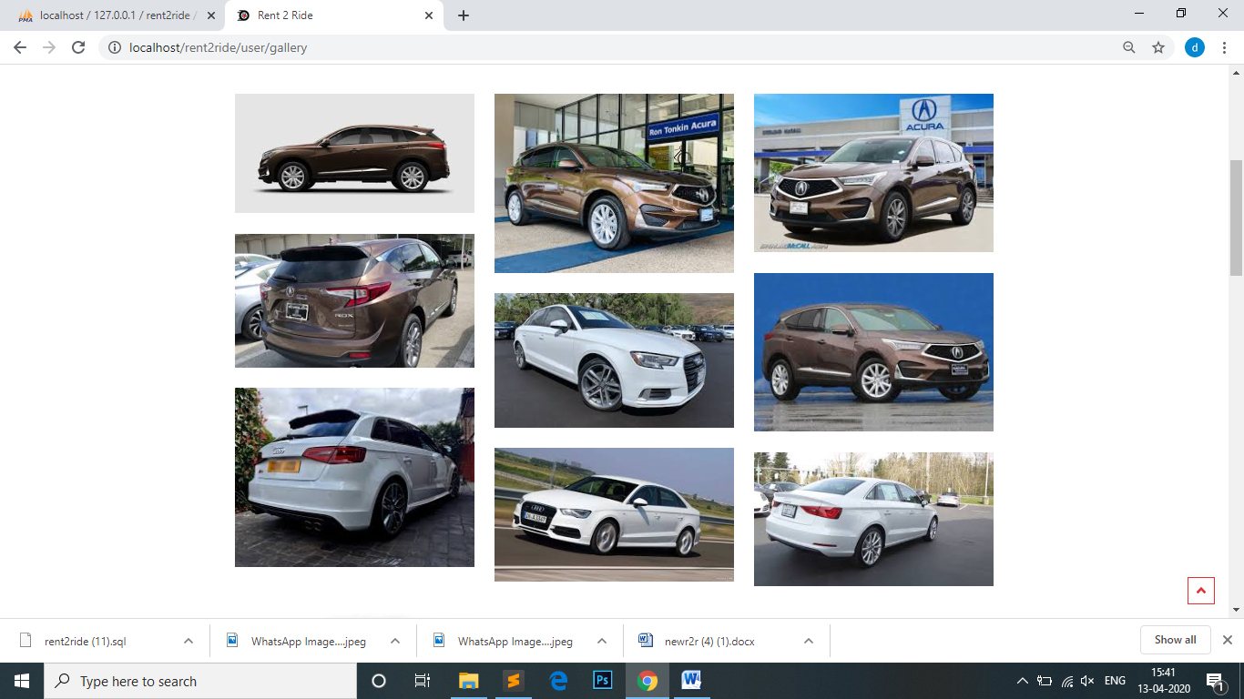**Gallery**

**Vehicle**

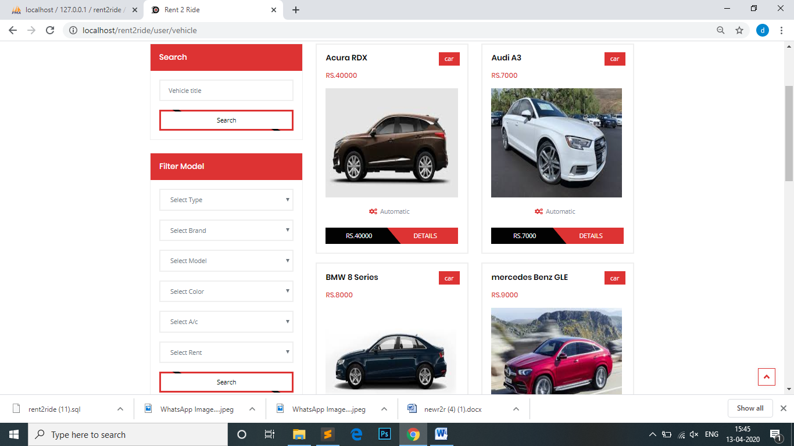

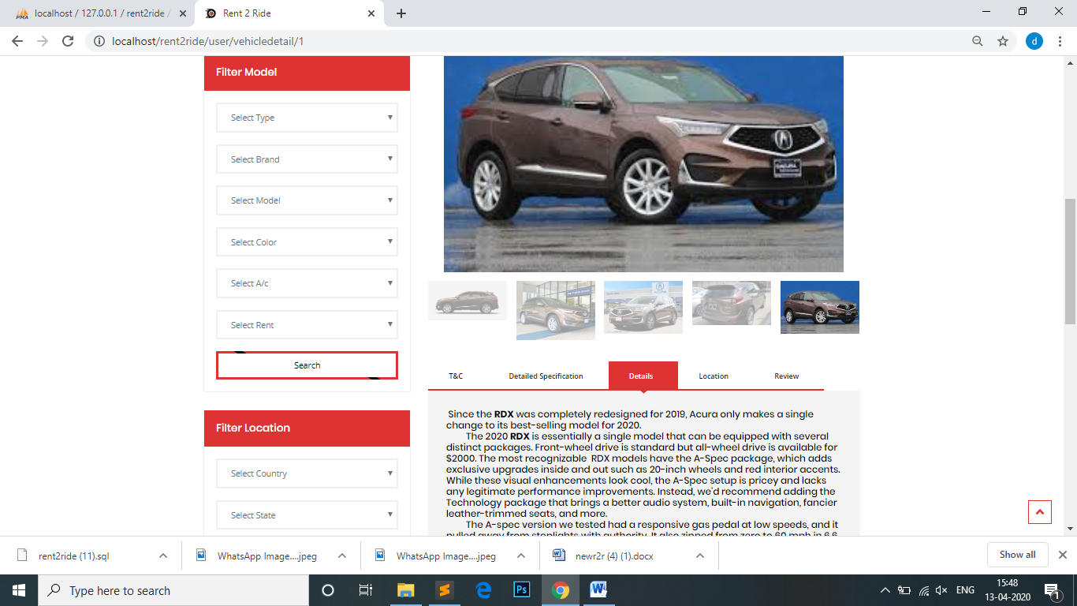**Vehicle Detail**

**Vehicle Booking**

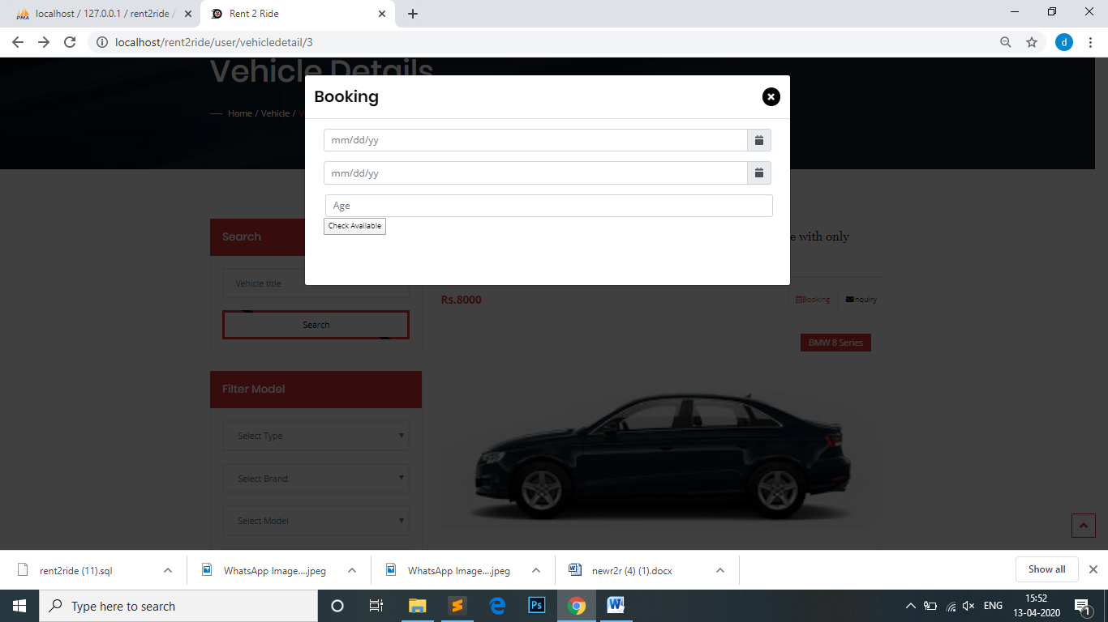

**Contact Us**

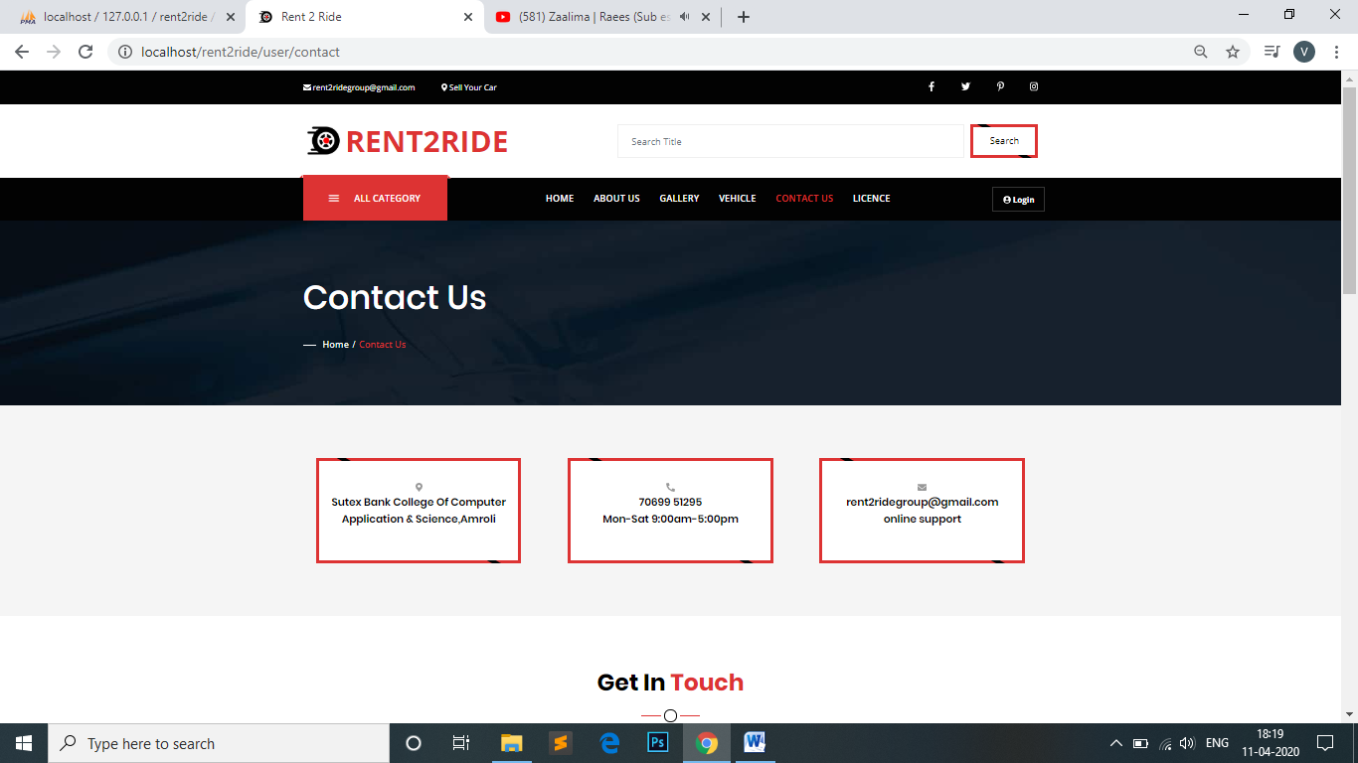

**Licence Form**

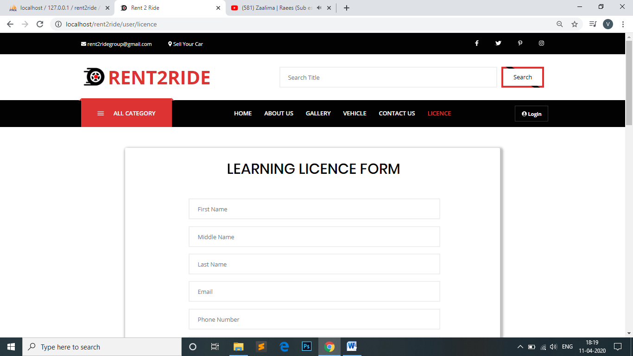

**7.1 Software Testing**

**7.1 Software Testing**

Software Testing is a critical element of software quality assurance and represents the ultimate review of specification design and coding. Testing is an exposure of a system to trial input to see whether it produces correct output. Testing cannot be determined whether software meets user`s needs. Onlywhether it appear to confirm to requirements. Testing can show that a system is free of errors. Only that is contains error. Testing finds errors, it does not correct errors. Software success is a quality product, on time and within cost. Though testing can revel critical mistakes. Testing should therefore.

1) Validate Performance

2) Detects Errors

Test Cases – Login module

|  |  |  |  |  |  |  |
| --- | --- | --- | --- | --- | --- | --- |
| **No.** | **Field Name** | **Input** | **Valid/**  **Invalid** | **Expected Output** | **Actual Output** | **Results** |
| 1. | Email Id | Null | Invalid | Please fill out this field | Please fill out this field | Pass |
|  |  | rajal.com | Invalid | Please match the request format | Please match the request format | Pass |
|  |  | rajal@gmail.com | valid | - | - | Pass |
| 2. | Password | Null | Invalid | Please fill out this field | Please fill out this field | Pass |
|  |  | Wrong Password | Invalid | Must contain at least one number and one uppercase and lowercase letter, and at least 8 or more characters | Must contain at least one number and one uppercase and lowercase letter, and at least 8 or more characters | Pass |
|  |  | Right Password | valid | Login | Login | Pass |

Test Cases – Registration module

|  |  |  |  |  |  |  |
| --- | --- | --- | --- | --- | --- | --- |
| **No.** | **Field Name** | **Input** | **Valid/**  **Invalid** | **Expected Output** | **Actual Output** | **Results** |
| 1. | Profile Pic | Null | Invalid | Please select a file | Please select a file | Pass |
|  |  | user1.doc | Invalid | Please match the request format | Please match the request format | Pass |
|  |  | user1.jpg | valid | - | - | Pass |
| 2. | Name | Null | Invalid | Please fill out this field | Please fill out this field | Pass |
|  |  | Rajal123 | Invalid | Please match the request format | Please match the request format | Pass |
|  |  | Rajal | valid | - | - | Pass |
| 3. | Email | Null | Invalid | Please fill out this field | Please fill out this field | Pass |
|  |  | rajal.com | Invalid | Please match the request format | Please match the request format | Pass |
|  |  | rajal@gmail.com | valid | - | - | Pass |
| 4. | County | Null | invalid | Please fill out this field | Please fill out this field | Pass |
| 5. | State | Null | invalid | Please fill out this field | Please fill out this field | Pass |
| 6. | City | Null | invalid | Please fill out this field | Please fill out this field | Pass |
| 7. | Area | Null | invalid | Please fill out this field | Please fill out this field | Pass |
| 8. | Password | Null | Invalid | Please fill out this field | Please fill out this field | Pass |
|  |  | Wrong Password | Invalid | Must contain at least one number and one uppercase and lowercase letter, and at least 8 or more characters | Must contain at least one number and one uppercase and lowercase letter, and at least 8 or more characters | Pass |
|  |  | Right Password | Valid | - | - | Pass |
| 9. | Confirm Password | Null | Invalid | Please fill out this field | Please fill out this field | Pass |
|  |  | Different | Invalid | Password And Confirm Password Are Not Match | Password And Confirm Password Are Not Match | Pass |
|  |  | Same Password | Valid | - | - | Pass |
| 10. | Phone Number | Null | Invalid | Please fill out this field | Please fill out this field | Pass |
|  |  | 12345 | Invalid | Please match the request format | Please match the request format | Pass |
|  |  | 1234567890 | Valid | - | - | Pass |
| 11. | Gender | Null | invalid | Please fill out this field | Please fill out this field | Pass |
| 12. | Address | Null | invalid | Please fill out this field | Please fill out this field | Pass |
|  |  | 75, Mansarovarsoc, Surat. | Valid | Registration | Registration | Pass |

**8.1 Limitations**

**8.2 Future Enhancement**

**8.3 References**

**8.1 Limitations**

* Our system indicates how mileage may lead; if it exceeds the limit you must pay a penalty defined by the rental agency.
* To return the car must be in the same place where it was delivered, otherwise they will be a charge penalty for changing the place of deliver.
* If there were problems with the bodywork and even the inner, the car rental company may charge a penalty for car repairs.
* To rent a car you must be over 18 years and with valid driving license from your own country and your passport.

**8.2 Future Enhancement**

* Add new car is representing the car list.
* Using Payment Gateways like Google Pay,phonepe , mobikwik,Paytm and Other Wallet Systems.

**8.3 References**

**Websites**

* www.code-project.com
* http://services.lovelycoding.org/car-rental-system/
* http://hyundai.com/in/en/utility/contact-us/enquiry/service-inquiry
* https://www.zoomcar.com/
* https://book.olacabs.com/rental-cabs
* https://drivezy.com/Bengaluru